**APA Structure (*Reference date: 26-Jun-2023)***

Now dynamic structure can be created. But previously there was no provision for automated preamble, signature and link table component features in the structure while preparing an APA format. Now the following feature has been implemented:

* Preamble (প্রস্তাবনা) and Signature (স্বাক্ষর) have been automated. User will set the preamble with some text and keywords. And when the subordinate office user receives the structure, he/she will select preamble component and need to click the save button, then the user’s designation and office will dynamically appear on the right side preview window.
* Two new components named “Acronym” and “SDG table” have been added. During structure creation, user now add these two.
* Now for every component, a toolkit/guideline has been added. While creating a structure, user can click on that toolkit icon. A message will guide the user to create that particular component.
* Now drag & drop feature is introduced. User can drag & drop any component.
* In the structure index page, user can now find any structure using fiscal year or structure name.
* When the subordinate office user will submit the final APA to the higher office, he/she will have the opportunity to put a scanned signature on the APA or this signature input process can be skipped if user does not want.
* When an activity is created, user can link data like goals, policies etc. This added data will appear in the annexure-4.

**Updated design:**

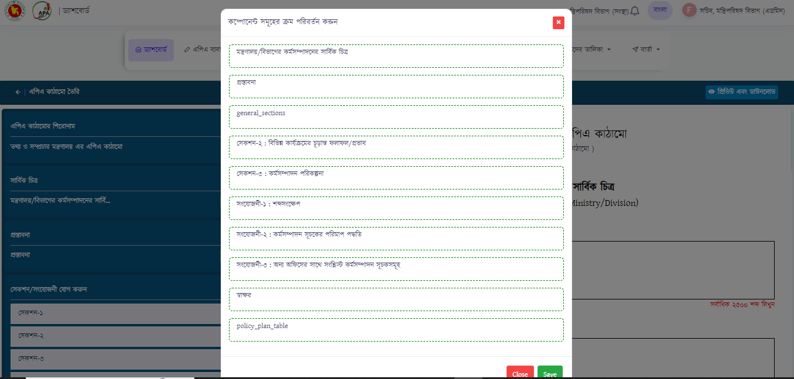

Figure: Drag & drop feature while preparing structure

**APA Preparation (*Reference date: 26-Jun-2023)***

### **Amendment**

The APA input design for an office user is changed. In this module, for every component, some changes are made during the demonstrations and based on client’s feedback.

* When user adds section-1, the sub-components (Such as mission, vision & functions) will be added as text box but the input process of strategic objectives will not be just as text box. This added strategic objectives will be visible in section-3 (Work plan table)
* **Section-2 input style:** The section-2 (Outcome/impact) input style has been changed. Now, user will find two tabs named “ফলাফল/প্রভাব পরিবর্তন করুন” and “কর্মসম্পাদন সূচক যোগ অথবা পরিবর্তন করুন”. User will add outcome first and after adding all outcomes, then he will select the second tab where user now adds performance indicator(s) against each previously added outcome. The added indicators can be updated or deleted. Lastly, user will add indicator-related information such as unit, actual achievement, target, projection, sources etc.
* While adding data in section-2, multiple rows can be generated against the first column (ফলাফল/প্রভাব)
* **Section-3 (Workplan table) input:** 
  + When user comes to section-3 (workplan) input part, the strategic objectives that were previously created in section-1 will appear in the side panel. User will find these added strategic objectives as tabs which can be expanded or collapsed.
  + Upon expanding a strategic objective, user will input the weight of that objectives and under this objective, activity field will appear where activity can be added.
  + After creating activity, user then add data like SDG Goals, plans/policies against that activity. These added policy-related data will appear in section-4 (SDG table) To add a performance indicator, user will find an add button below the activity field.
  + When a performance indicator is added under an activity, user now can add additional information about that indicator like weight, unit, unit measurement, target, actual achievement and projection etc. Thus, user can add more indicators against that activity.
  + While preparing APA, user now can put comment on every component whether it is text component or table. Also, performance indicator-wise comments can be made by maker and higher office user.
  + User can up and down an indicator using up/down arrow. And, a strategic objective can be …..
  + While preparing APA, if user wants, then he/she can assign this particular indicator to a subordinate office.
* User now add acronym in different style.
* Annexure-4 or SDG Table has been added. When policy, goal, plans etc. related are added to an activity, then these data will appear in this particular table.

**Updated design:**

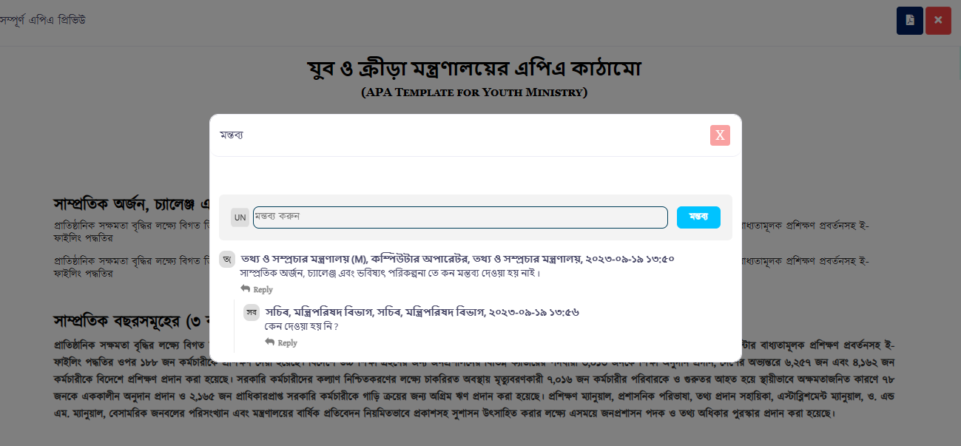

Figure: Comment on text box component

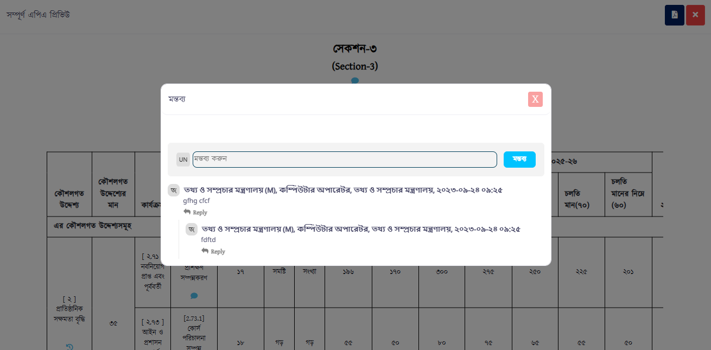

Figure: Comment on table component

**APA Submission time setting (*Reference date: 26-Jun-2023)***

In APA submission time setting, a new feature has been introduced. User can enable the timeline setting for the offices. If the timeline settings is enabled, then offices will be able to see the timeline for the APA submission. Otherwise, an office will not see that timeline.

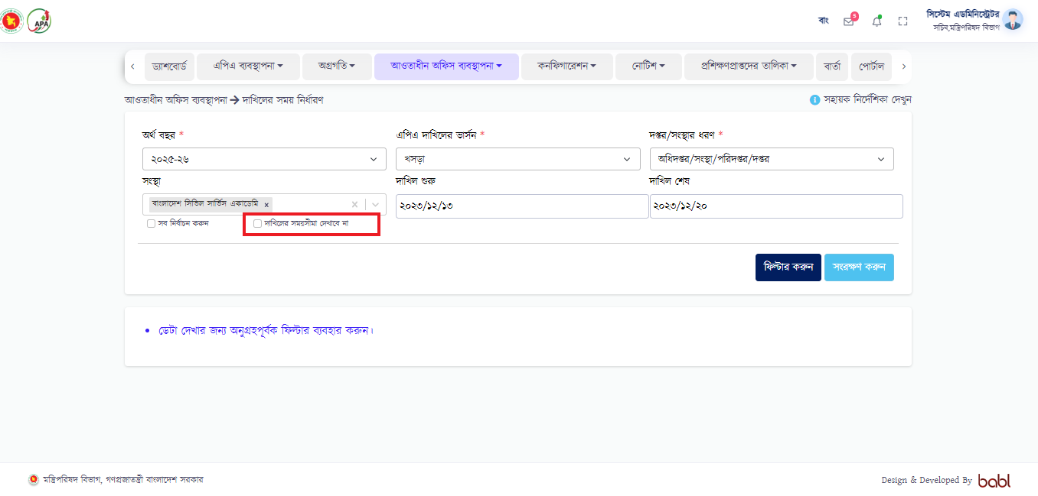

**APA Edit request (*Reference date: 26-Jun-2023)***

After submitting the APA, it is often necessary to edit the APA again. To open the APA, the subordinate office makes a request with a message to the higher office before the submission deadline. When the higher office is about to accept the request, a modal will appear where there will be a text box for comment, a new timeline and the list of performance indicators. Higher office user unchecks indicator from the list and accepts request. Finally, for the subordinate office user, his/her APA will be open but only those indicators will remain open.

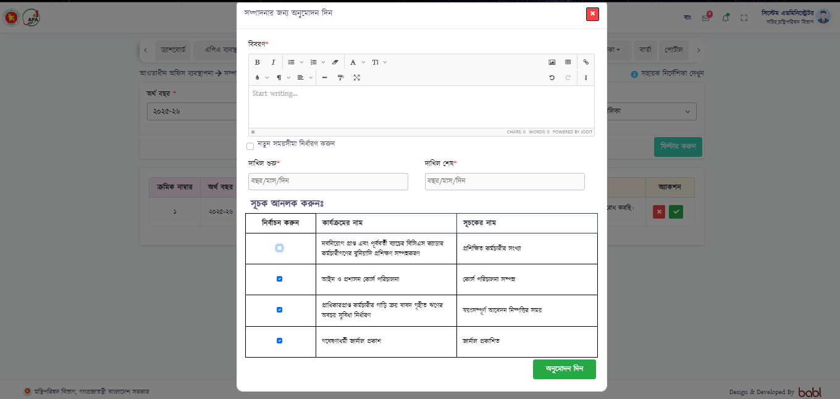

### **3.2.5 APA edit history (Amendment)**

### 3.2.5.1 Use Case Table

|  |  |
| --- | --- |
| Name | APA edit history check |
| Brief Description | User will send edit request to his/her higher office after successful APA submission. When higher office user accepts the request, then the APA of subordinate office is unlocked and can edit. Whenever, any changes are made during edit, there will be have a history of that edit. |
| Actor | * Admin * Office user (Checker) |
| Pre-Condition | * APA is submitted to higher office. * APA edit request made by user. * APA edit request is accepted by higher office. * User edits any part of APA & resubmits it to higher office. |
| Business Rules | * Subordinate office user will send an update/correction request to his higher office in order to reopen his APA which will be locked after final APA submission. * After APA edit request is accepted and unlocked by higher office, user will find his/her office APA unlocked. * Office user then edits any part of APA and resubmits to higher office. * Higher office user then receives the newly submitted APA. There is icon besides every component of an APA. Upon clicking on that H.O user can experience what part was updated. After updating, user can see the new part which was added/edited. |
| Post-Condition on Success | On submit a success message will pop up like “Assigned APA successfully” |

3.2.5.1 Mock design

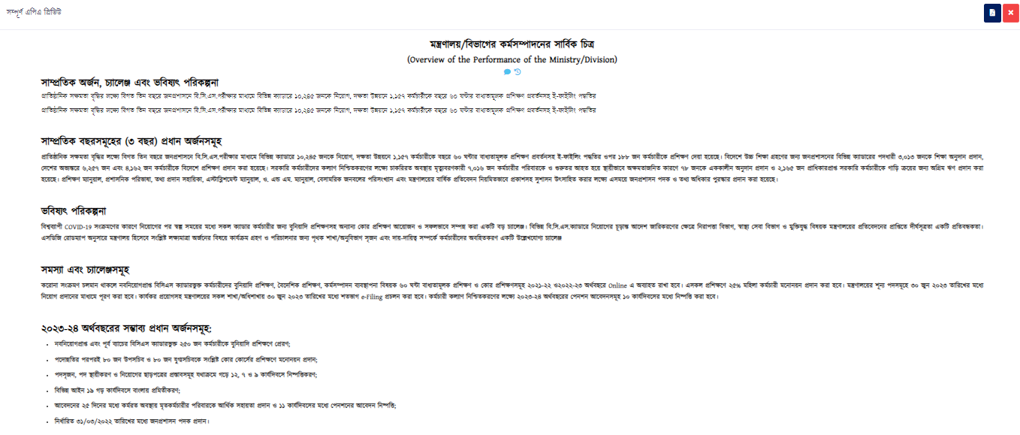 Figure: Full APA preview before see edit history

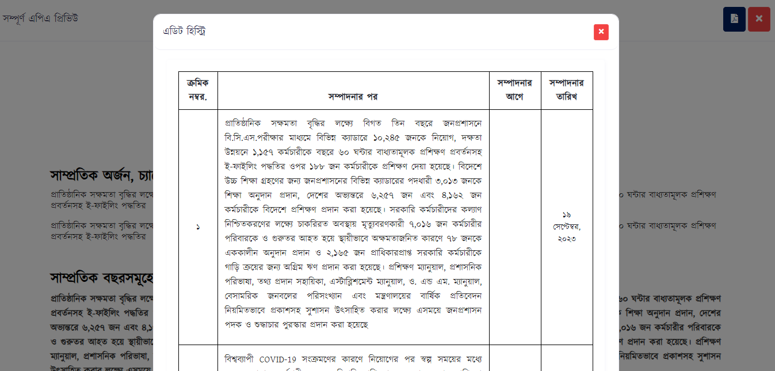

Figure: See edit history

**Mandatory Weight (*Reference date: 26-Jun-2023)***

Basically, user defines the whole APA number and the mandatory weight for a specific organogram before assigning an APA. Now, a feature has been implemented ********** (To be)

**APA Calendar (*Reference date: 26-Jun-2023)***

The interface of the calendar has been changed. Now user will be able to create an event by selecting date, month and year. Upon selecting a date, a pop-up will appear where there are the following fields:

* Name of event* (Bn)
* Name of event (Eng)
* Organogram*
* Start Date*
* End Date*
* Start Time
* End Time
* Details

After filling all these fields, an event will be created against that organogram. And when the users of that organogram log in to system, this event will appear on their dashboard.

**APA Correction time setting (*Reference date: 26-Jun-2023)***

When the final APA is submitted, it may require to edit the APA once again as per requirement. In order to do it, a higher office user/the cabinet user sets the time for an entire organogram or even for an office. Higher office user/the cabinet user enters the APA correction time setting menu and fills the following fields:

* Fiscal Year [Dropdown]
* Organogram [Dropdown]
* Office [Dropdown]
* Submission time starts [Calendar]
* Submission time end [Calendar]
* Rate of change of indicator (%) [Numeric]

Here, user sets the rate of change of indicator which means that an office cannot change its indicators more than that. Suppose, if user sets 10% indicator change for an office and say, that office has total 30 indicators in its APA, then that office user can change any 3 (10% of 30) indicators of its APA.

**APA Correction by user (*Reference date: 26-Jun-2023)***

A user will be notified when the APA correction time is set by higher office. The user needs to go “APA Correction” module. There user will find the section- 3 (Workplan). The process is given below:

* User first select a strategic objective from the strategic objective dropdown;
* User then selects activity under that strategic objective;
* Then selects a performance indicator under an activity;
* Finally, user makes change in an indicator and saves it;
* When any data is changed, it can be visible in the preview window in green color under that existing data;
* User can make change in some indicators only. In the preview window, user will be able to see the number of indicators which can be changed. After making all changes, all the fields will be disabled.;
* Higher office user receives that request and accept/reject that correction request;

**APA Achievement entry (*Reference date: 26-Jun-2023)***

In the APA achievement module, the user input process and design are same. But after successful achievement entry by a user, the achievement view design under the input design will be different. Based on client’s feedback:

* The whole APA table will be visible only when a button will be clicked;
* During achievement entry when the user selects an indicator, the view table will show that selected indicator only having these data: performance indicator, achievements on four quarters/12 months and total achievement till now.

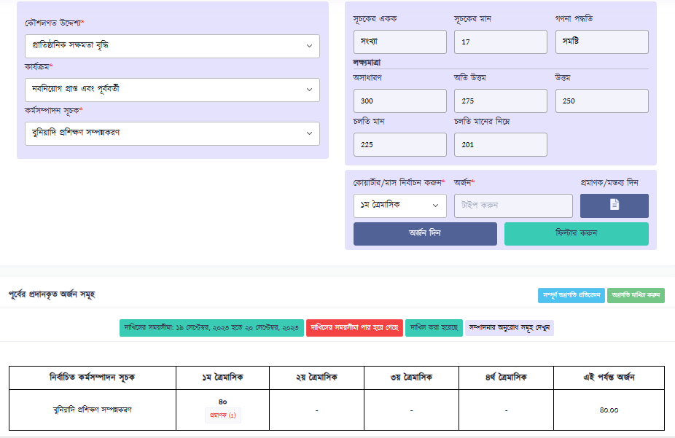**Updated design:**

Figure: Achievement entry against a performance indicator

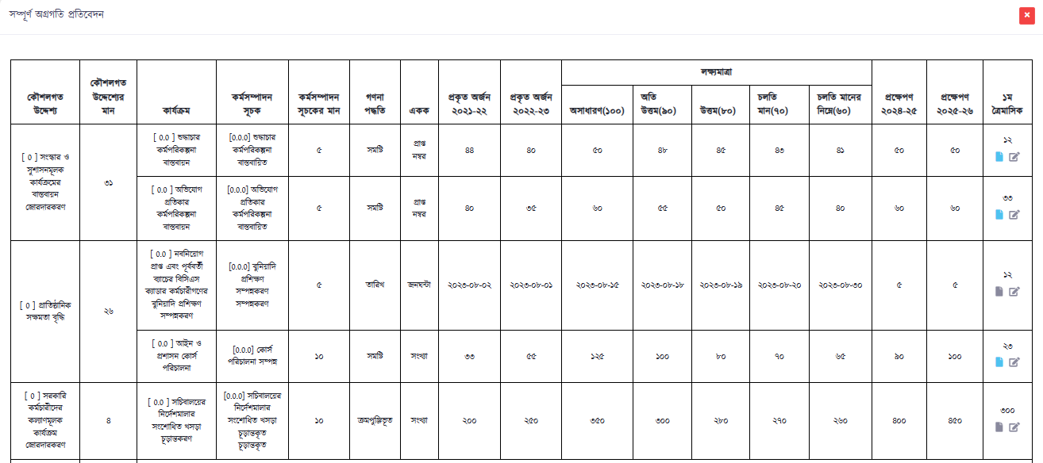 Figure: Overall achievement view page

**Audit (*Reference date: 26-Jun-2023)***

An audit module in software is a component or feature designed to facilitate the auditing and monitoring of various activities within the system. The primary purpose of this module is to track and record user actions, system events, and changes to data. This functionality is crucial for maintaining security, ensuring compliance with regulations, and troubleshooting issues within the software. It has the following fields:

* Module type [Dropdown]
* Organogram [Dropdown]
* Office [Dropdown]
* Submission time starts [Calendar]
* Submission time ends [Calendar]
* Event [Dropdown]

The process of this functionality is given below:

* In the module type, user first selects a functionality like APA structure, strategic objectives, activity, indicator, achievement etc. will be in the dropdown.
* Then user has to select ministry/divisions, department from the dropdown and selects an office against the selected organogram;
* Then the user selects start date and end date;
* Finally, user needs to select an event e.g. create, edit and delete. Upon selecting filter, a list will appear in the table. There is an action button where user can see the history of that action.

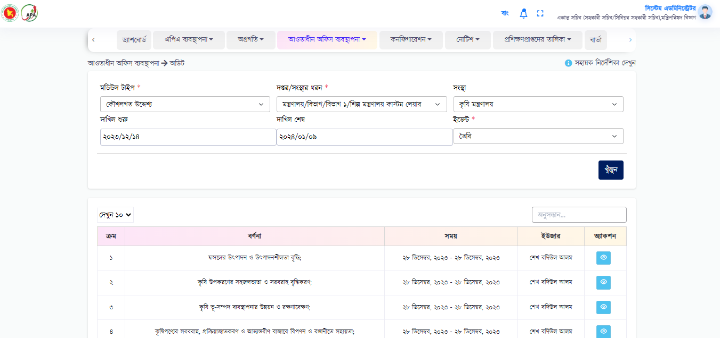

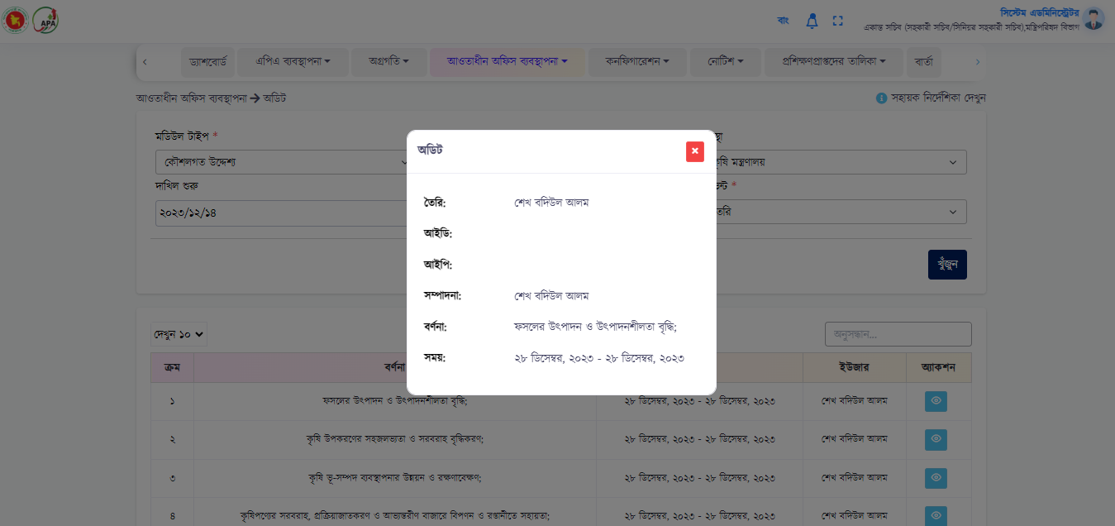

**Publication (*Reference date: 26-Jun-2023)***

A new functionality has been introduced. User will able to publish any document or image which will be displayed at the landing page of this software. Government offices often conduct training, meeting or workshop sessions for many purposes. In those training, meeting or workshop sessions, many books, documents, notes are published and photos are taken. And, these documents, books and photos are published in websites. Now, user will able to do similar thing in this software.

**Required Fields:**

* Title * (Text field)
* File (Upload)*
* Thumbnail (Upload)*
* Description

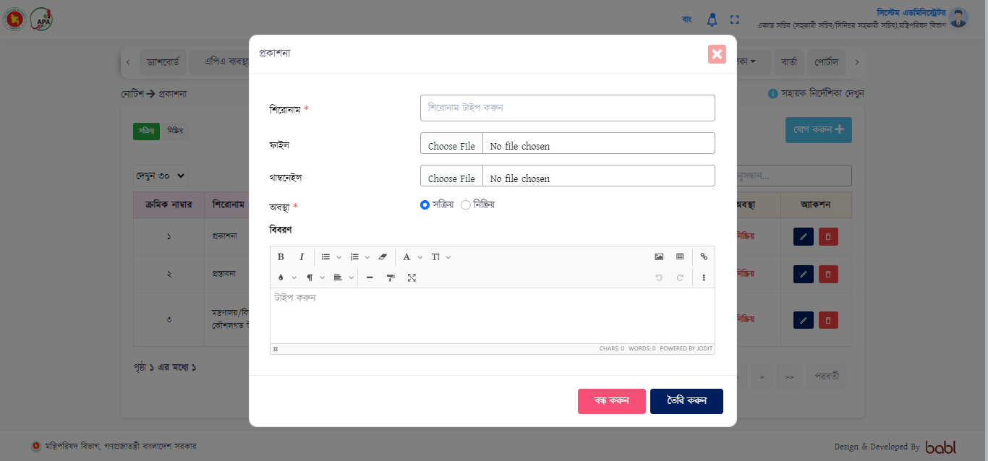

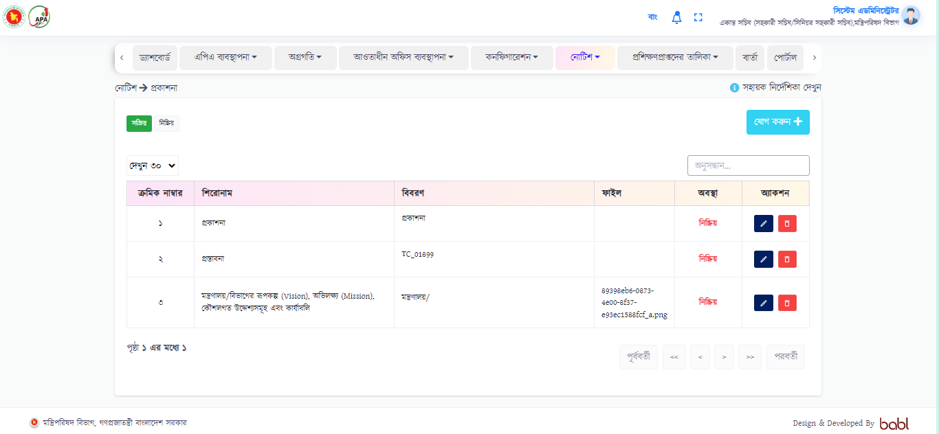

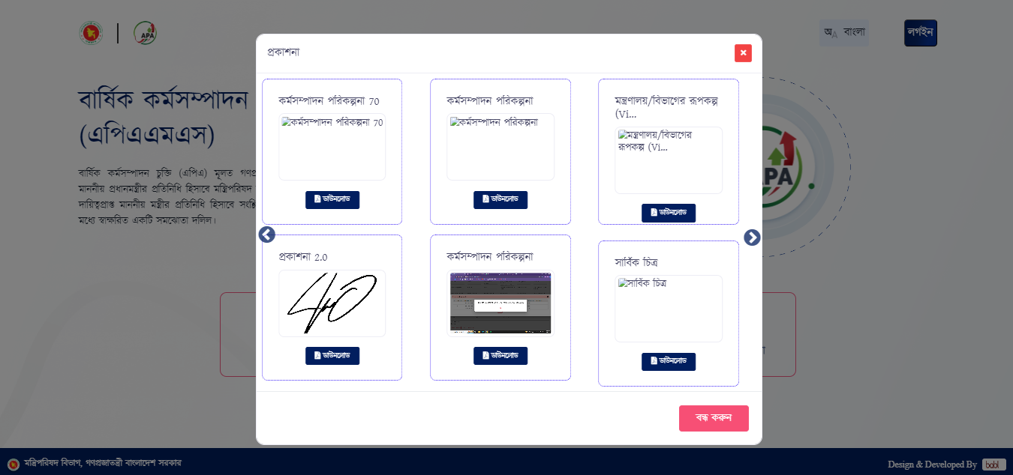

**Configuration**

**Frequently Asked Questions (FAQ)**

This section in the APAMS v3 system indicates some frequently asked questions about the Annual Performance Agreement Management System software and the answers according to those questions. Basically, an admin user will create this questions and answers on this particular section. As a result, whenever, an outside user or a user who is using the software for the first time will get to know about this system. The process is given below:

1. User will go to the configuration menu and selects FAQ from it;
2. There will be an add button and a modal will appear when this add button is being clicked;
3. User then writes a question in the question field and answer in the answer field and saves;
4. Thus user can add multiple questions like this and these added question and answers will appear in a list view;

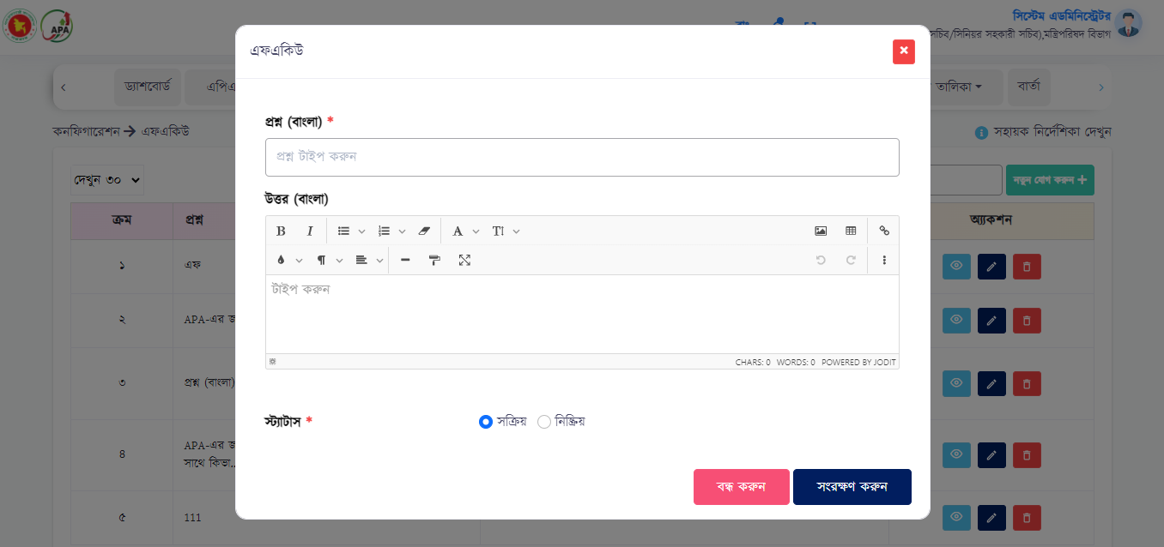

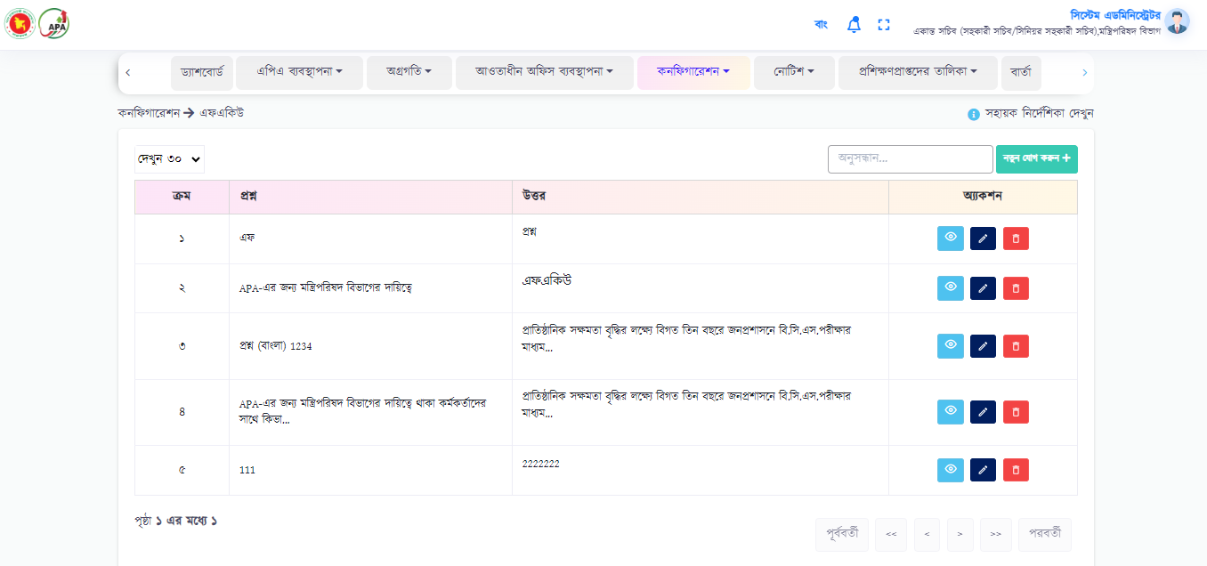

**Master Data**

**Notice type**

A user will create notice type under this sub-menu.User will create notice for sub-ordinate offices. Basically, user will create notice category first. For example, user creates a notice type category like achievement submission date first. Then when the user is going to create a notice for subordinate offices, then he/she needs to select the notice category first before creates a notice. Thus, user creates multiple notices under a category. All these notices under multiple categories will be visible at the landing page.

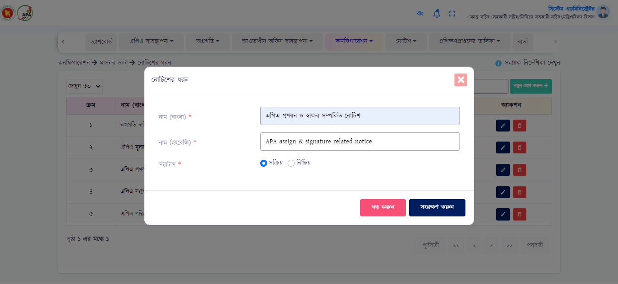

**Portal**

The portal has been introduced as a new concept for the APAMS users. The objective of this functionality is to create and manage various contents like documents, images and presentation for learning purpose. The functionality is quite simple and the use case is given below:

* User will select “Portal” from the menu. This functionality is open for all users as any user can upload any files to this platform;
* Then select “Upload Content” button and a modal will appear where user needs to fill the following fields:
  + Title*
  + File /image name *
  + Link (not mandatory)
  + Details*
* Upon clicking save button, the content will be uploaded and will be shown in the list;

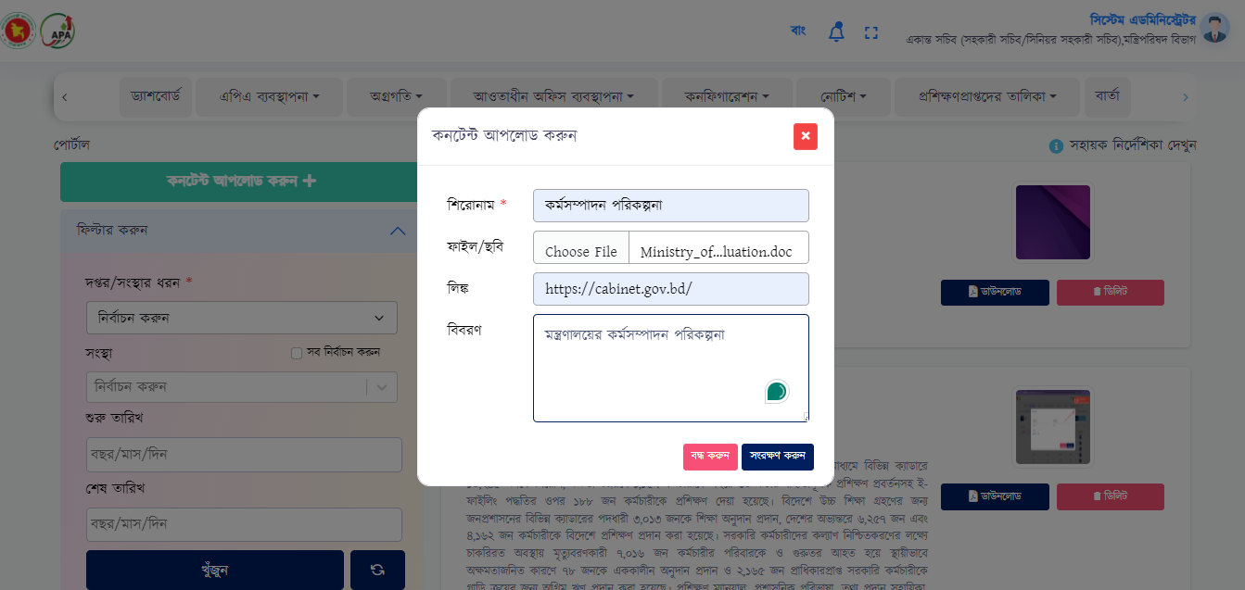

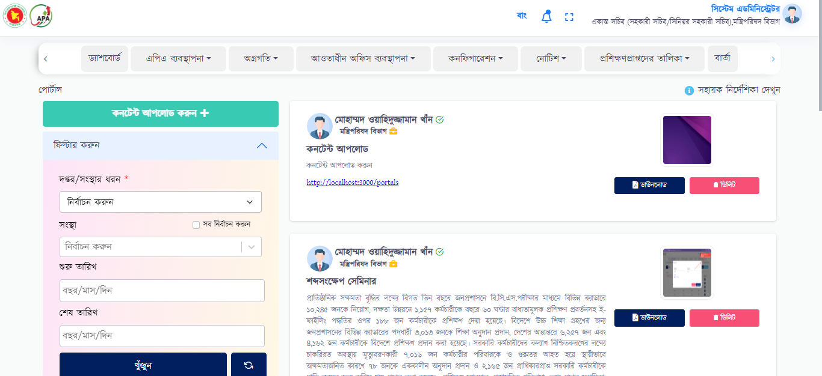

* User can find any content using the selected fields;

**Configuration**

1. Role & permission

In Role & permission section there will be six different Sub module that user will be used for making role permission. Those features are given below:

* + **Main menu->** Main menus will be created here, which will be seen on the system display. User can edit and cancel from action column.

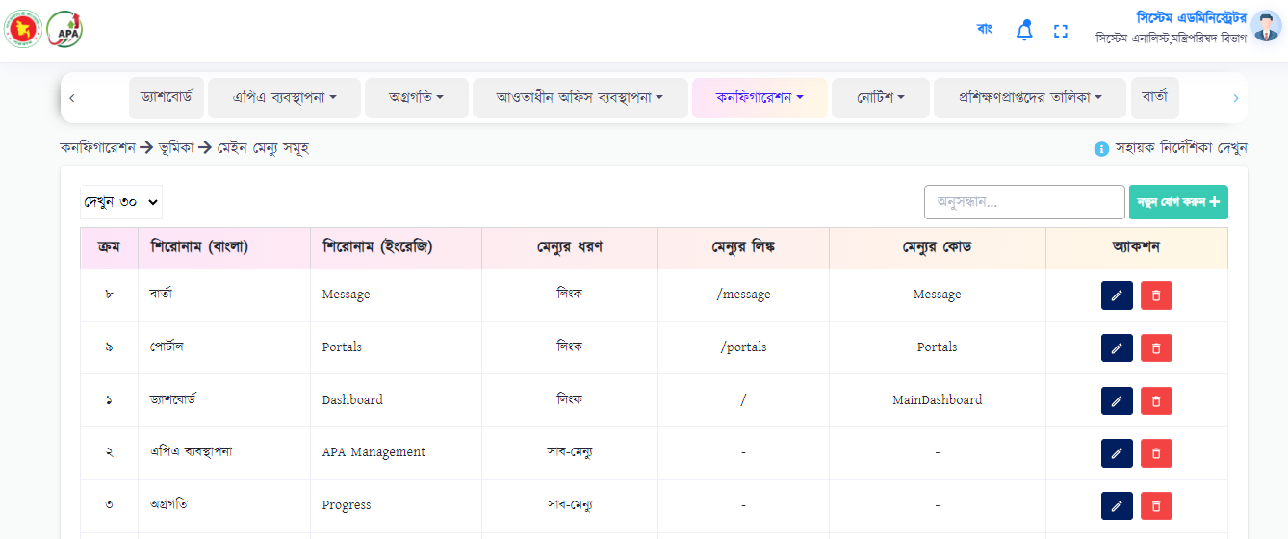

User will click “Add New” button to add new data. To add new data, user needs to fill the following fields:

* + Title BN, EN*
  + Menu Type*
  + Menu Code*

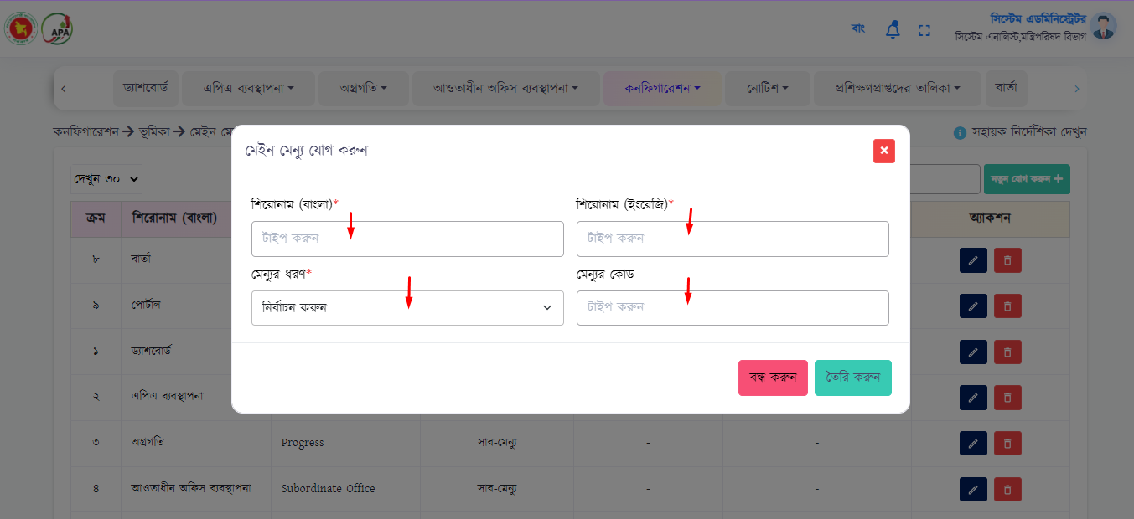

Upon clicking on create button, the data will be uploaded and will be shown in the list.

* + **Sub menu->** Sub menus will be created here, which will be seen on the system display. User can edit and cancel from action column.

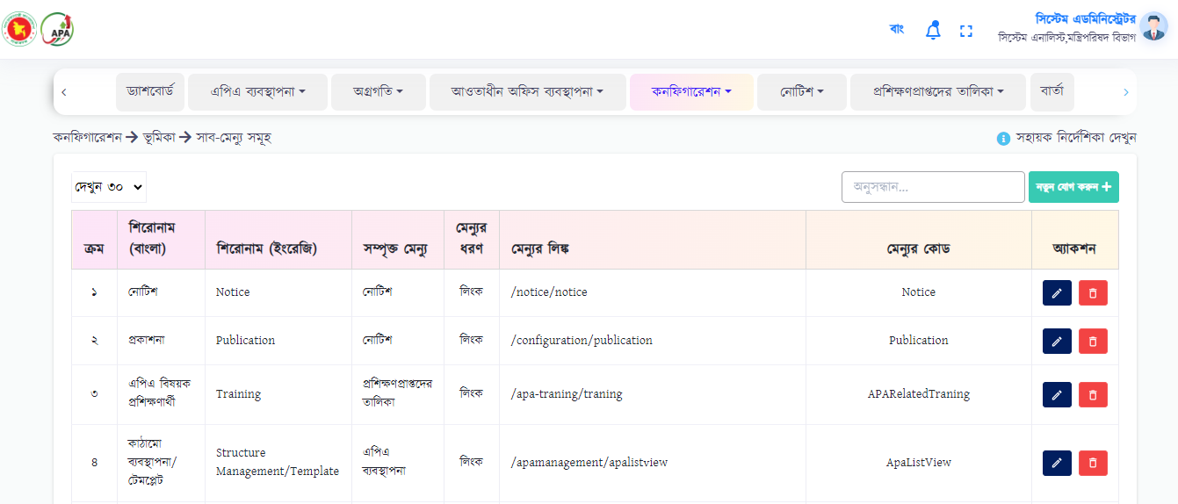

User will click “Add New” button to add new data. To add new data, user needs to fill the following fields:

* Main Menu*
* Title BN, EN*
* Menu Type*
* Menu Code*

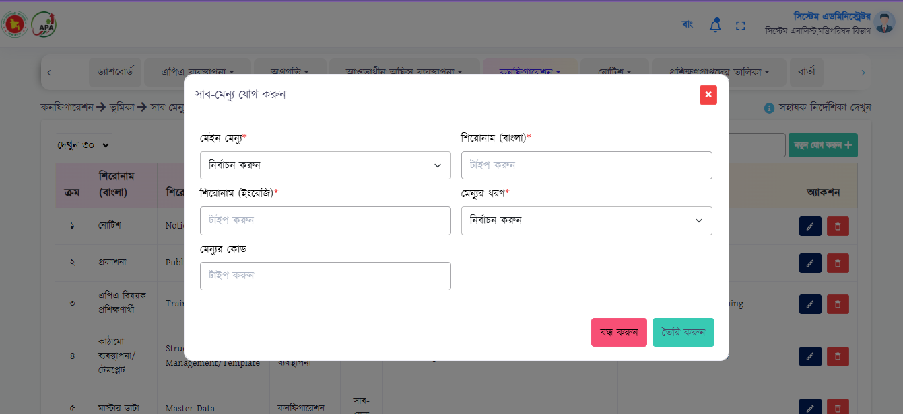

Upon clicking on create button, the data will be uploaded and will be shown in the list.

* + **Sub, Sub-menu->** Sub, sub-menus will be created here, which will be seen on the system display. User can edit and cancel from action column.

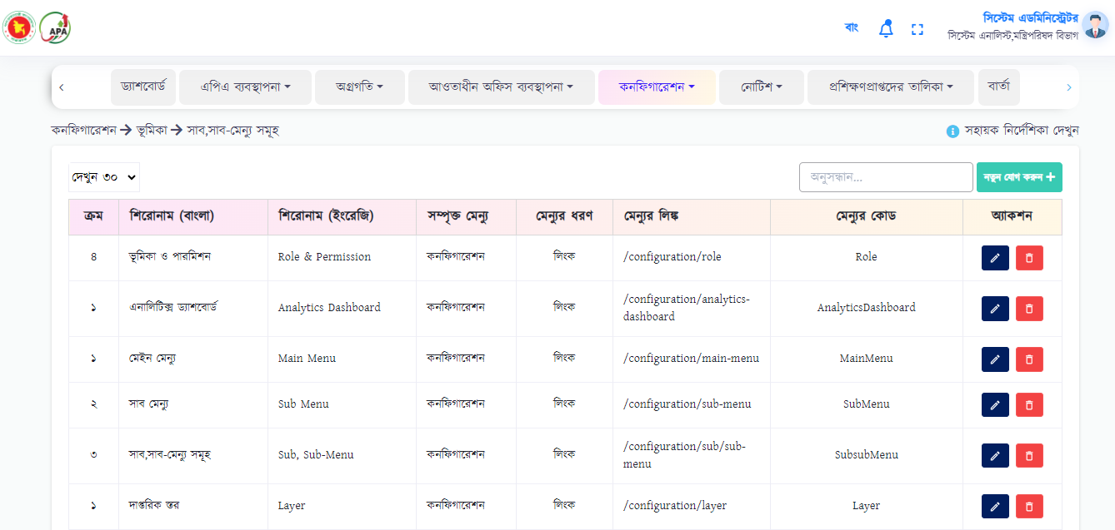

User will click “Add New” button to add new data. To add new data, user needs to fill the following fields:

* Main Menu*
* Sub Menu*
* Title BN, EN*
* Menu Link*
* Menu Code*

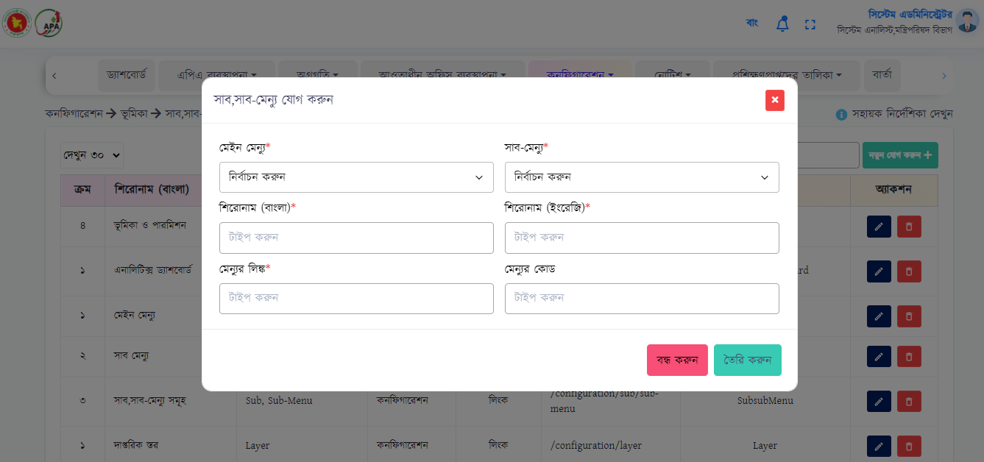

Upon clicking on create button, the data will be uploaded and will be shown in the list.

* + **Role & Permission->** In this menu, the dashboard will be selected according to the user's role. User can view, edit and cancel from action column.

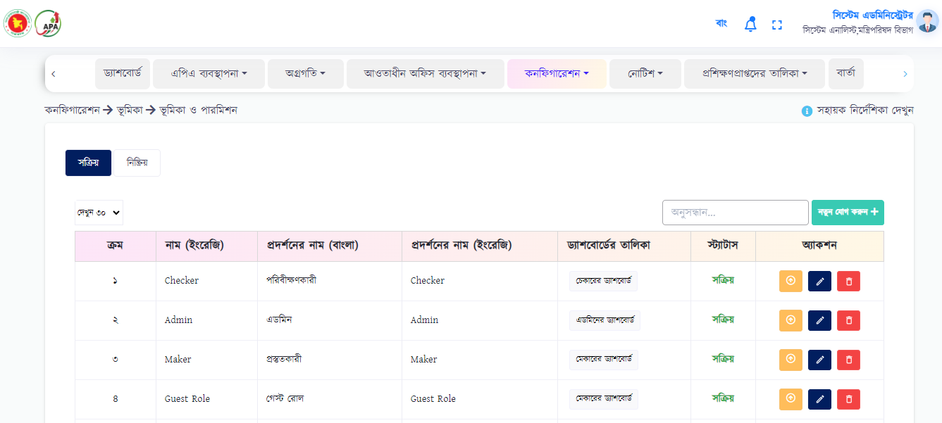

User will click “Add New” button to add new data. To add new data, user needs to fill the following fields:

* Name EN*
* Display Name BN, EN*
* Select Dashboard (Drop down) *
* Status (Active & Inactive) *

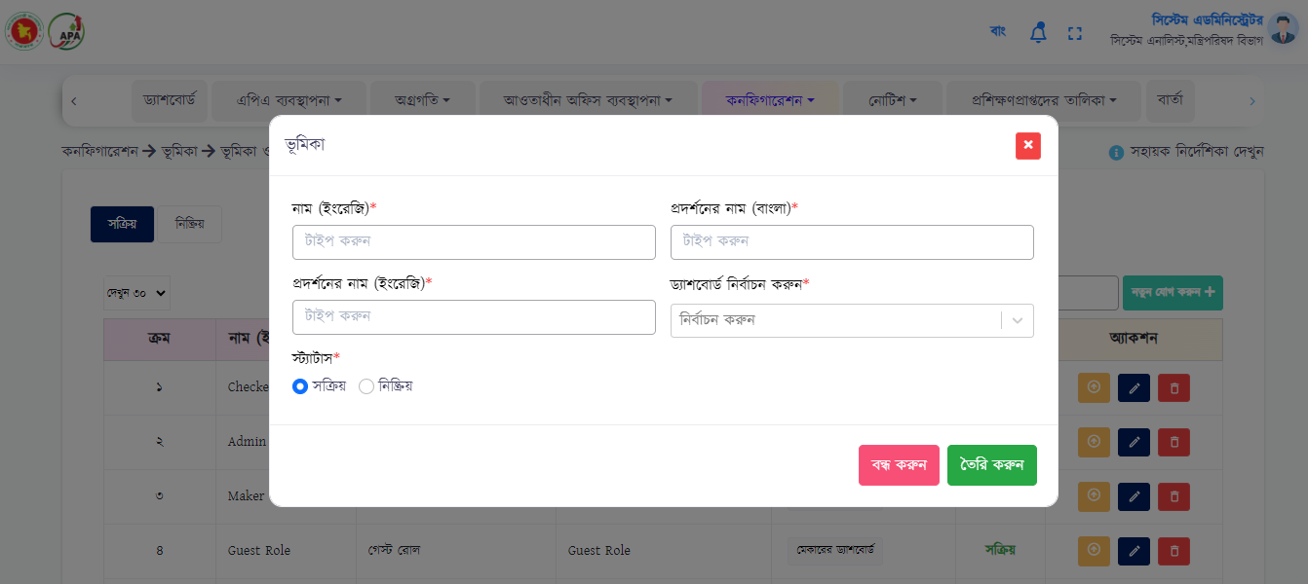

Upon clicking on create button, the data will be uploaded and will be shown in the list.

* + **Job Profile->** In this menu, roles will be selected according to the user's job profile. User can edit and cancel from action column.

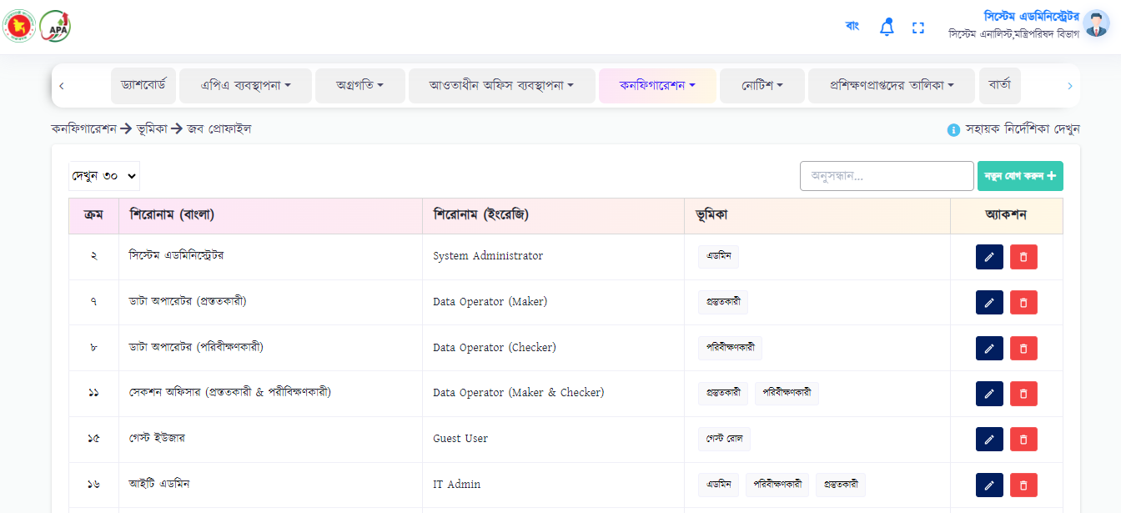

User will click “Add New” button to add new data. To add new data, user needs to fill the following fields:

* Title BN, EN*
* Role Type (Drop down) *

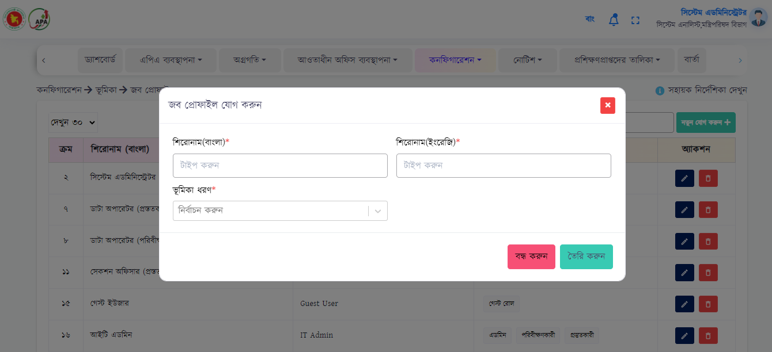

Upon clicking on create button, the data will be uploaded and will be shown in the list.

* + **User Profile->** In this menu, roles will be selected according to the user's layer and office.

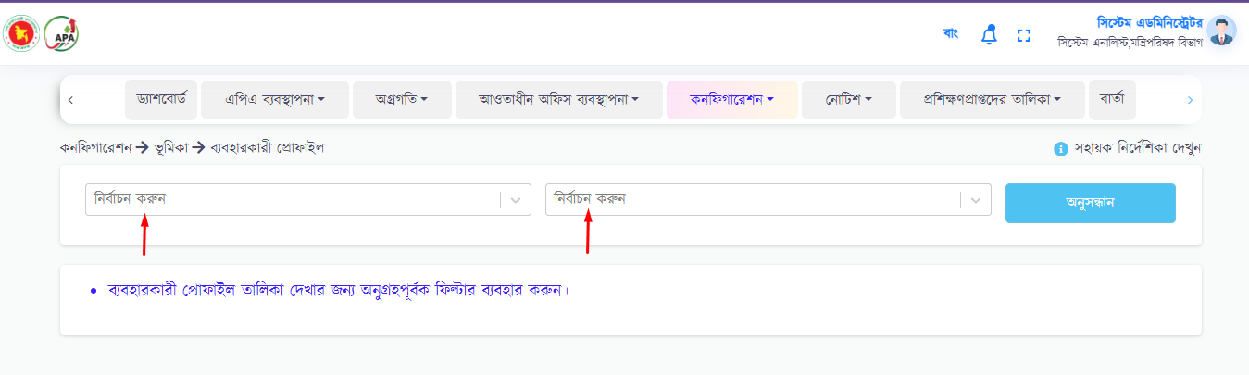

To view data, user needs to select layer & office from drop down. User will click “Search” button to see data.

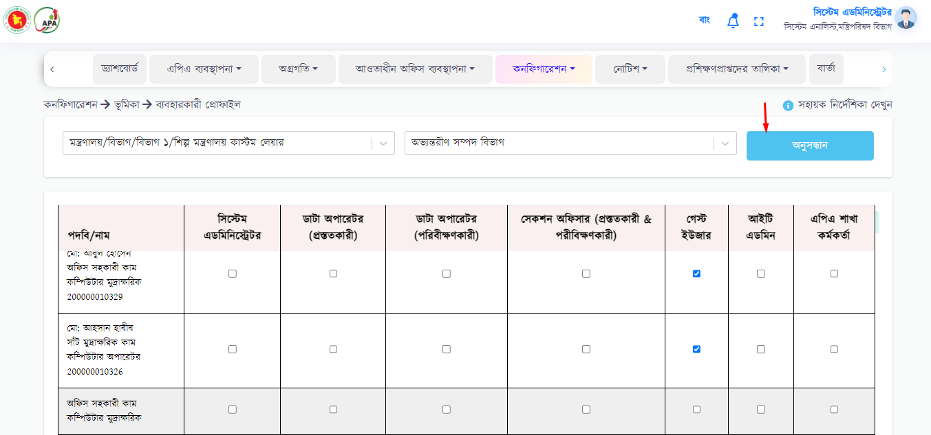

Upon clicking on search button, the data will be shown in the list.

1. FAQ

This menu creates questions and answers, which will be appear on the landing page. User can view, edit and cancel from action column. To add new data, user will able to click on “Add New” button to add new data.

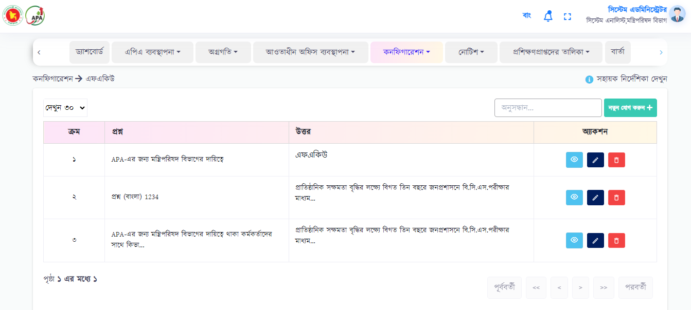

There user can see following fields:

* Question BN
* Answer BN
* Status (Active, Inactive)

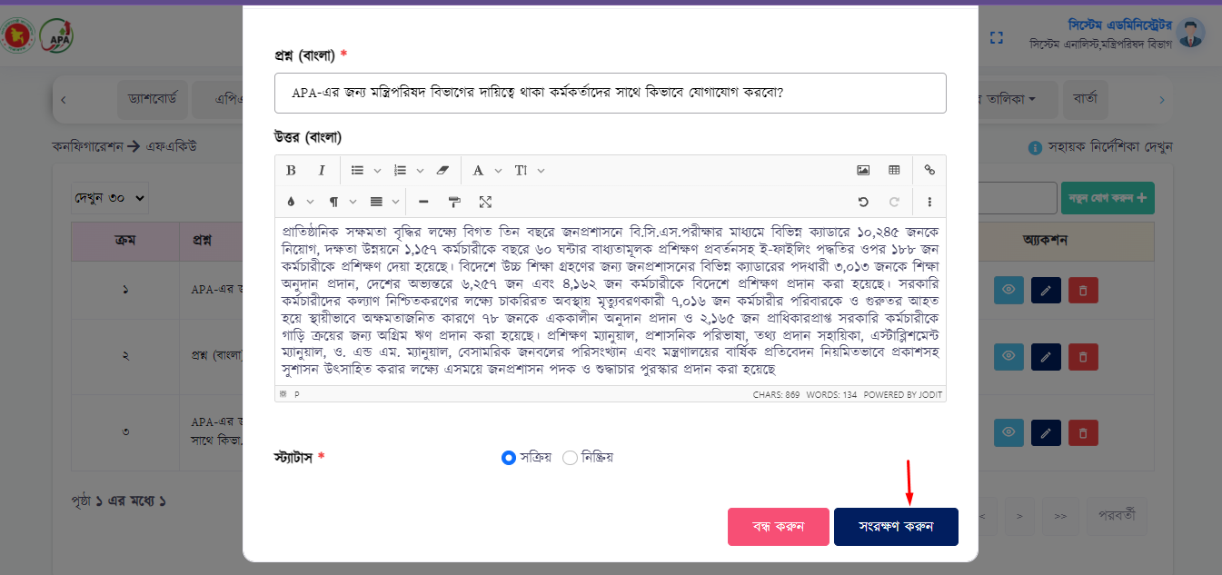

Upon clicking on save button, the data will be uploaded and will be shown in the list.

1. Hierarchy

This menu shows the department/organization type according to the official level that sent from the Nothi. Note that, user can’t create new 'Office/Organization Type'. It directly came from Nothi.

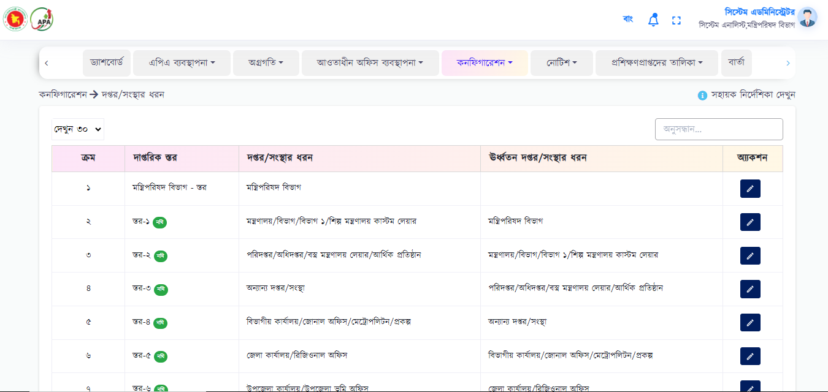

There user can see following fields:

* Official Layer
* Type of Office/Organization
* Type of Higher Office/Organization

If user can be edit here also.

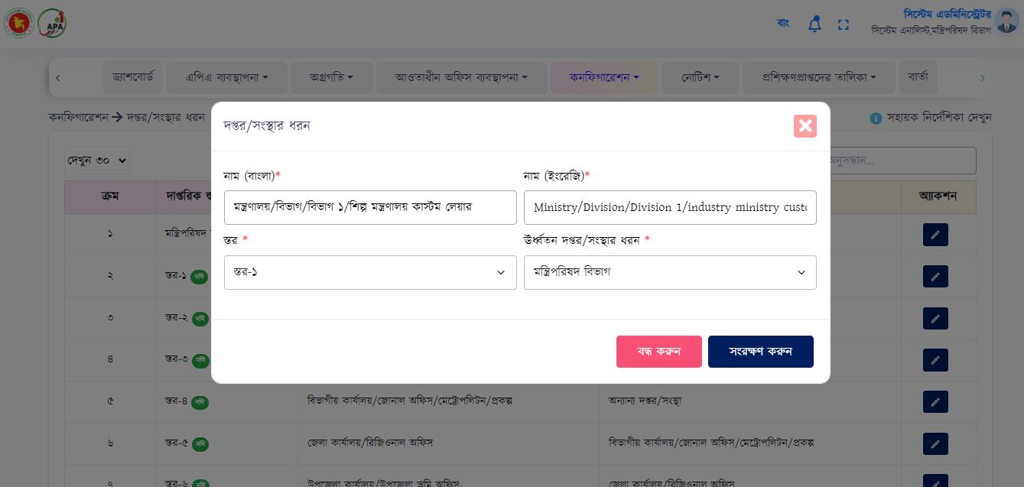

After edit, clicking on save button, the data will be uploaded and will be shown in the list.

1. Master Data

* **Layer->** This menu will be showing the official level that sent from the nothi. Note that the user cannot create a new 'Official level'. User can only view the data.

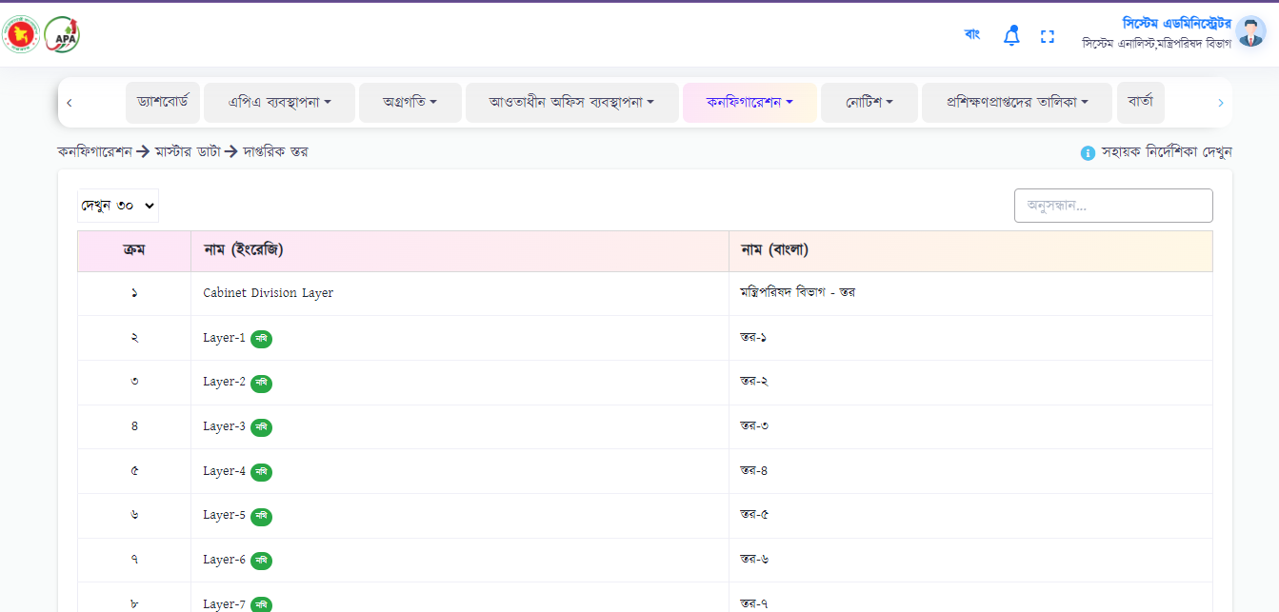

* **Designation->** This menu shows the names and codes that sent from the nothi. It should be remembered that the user cannot create a new 'designation'. User can only view & edit data.

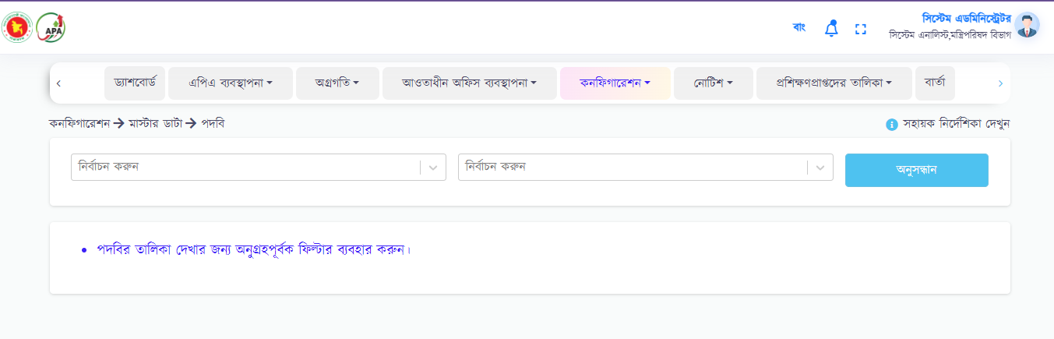 To view data, user needs to select layer & office from drop down. User will click “Search” button to see data. Upon clicking on search button, the data will be shown in the table.

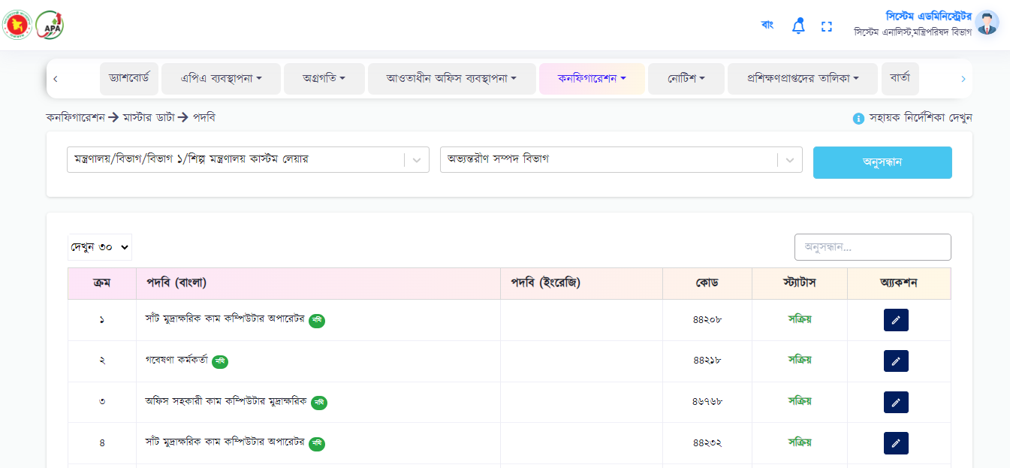

To edit, user will fill three fields. That are:

* Name BN, EN*
* Code*

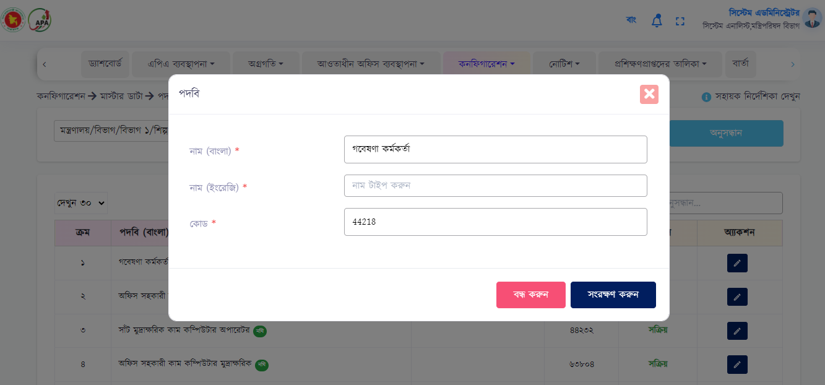

After edit, clicking on save button, the data will be uploaded and will be shown in the list.

* **Notice Type->** In this menu the type of notice will be create, which will be tagged while creating the notice. Here user will add, edit & delete data. User will click “Add New” button to add new data.

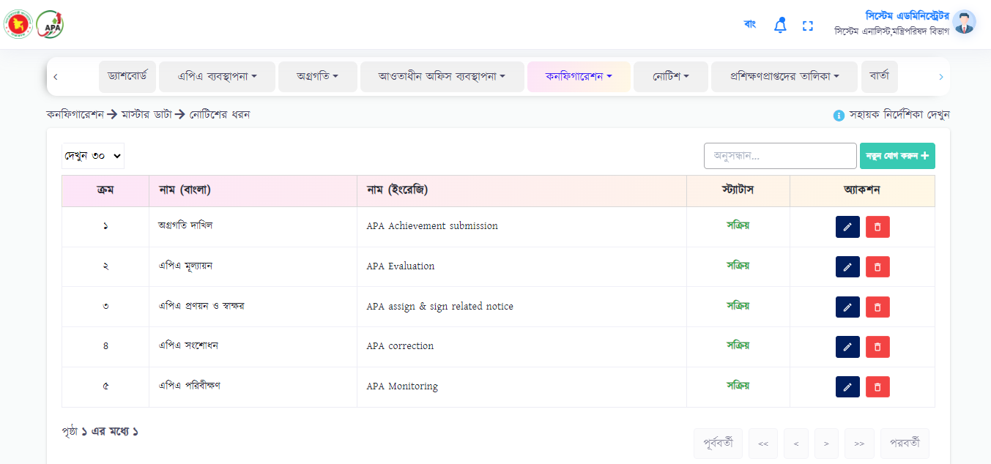

To add new data, user needs to fill the following fields:

* Title BN, EN*
* Status (Drop down) *

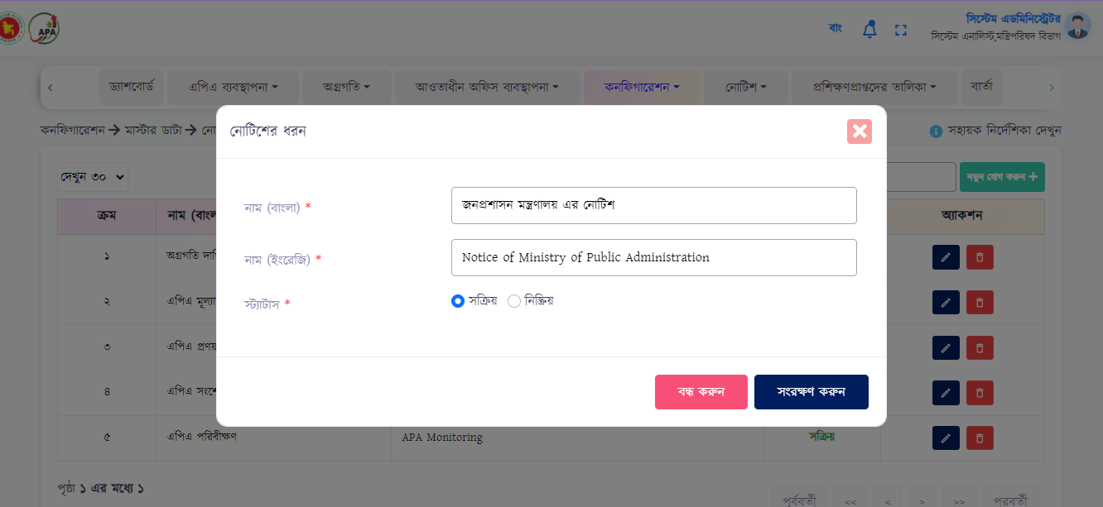

Upon clicking on create button, the data will be uploaded and will be shown in the list.

* **APA Toolkit->** In this menu 'guidelines' will be created, which will be specified while creating the structure/template. Here user will add, edit & delete data. User will click “Add New” button to add new data.

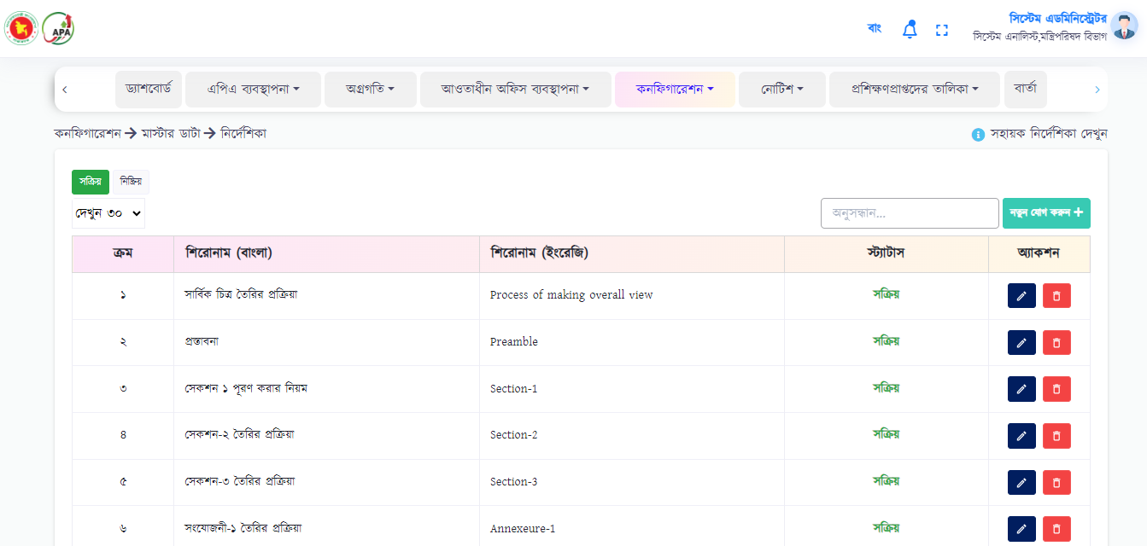

To add new data, user needs to fill the following fields:

* Title BN, EN*
* Status (Drop down) *
* Details

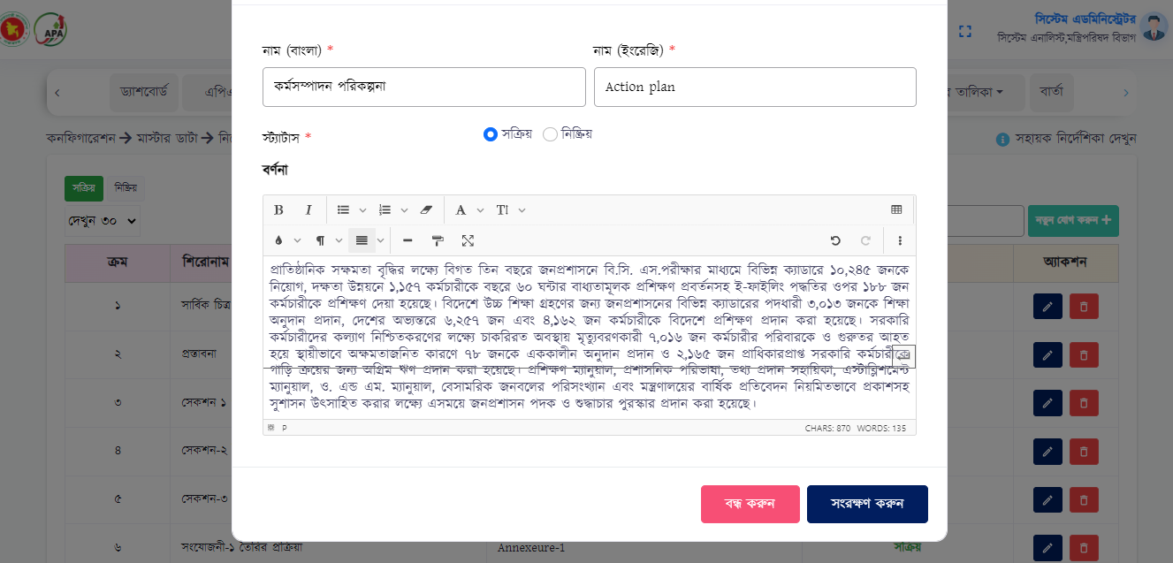

Upon clicking on create button, the data will be uploaded and will be shown in the list.

* **Activity Related Data Category**-> In this menu 'Performance Information Category' will be created, which will be mentioned while creating Annexure-4. Here user will add, edit & delete data. User will click “Add New” button to add new data.

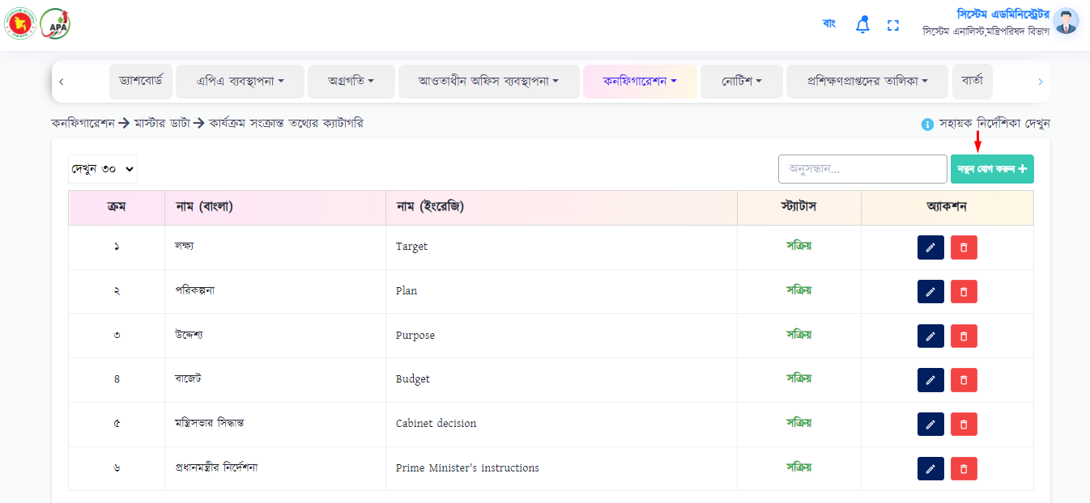

To add new data, user needs to fill the following fields:

* Name BN, EN*
* Status (Drop down) *

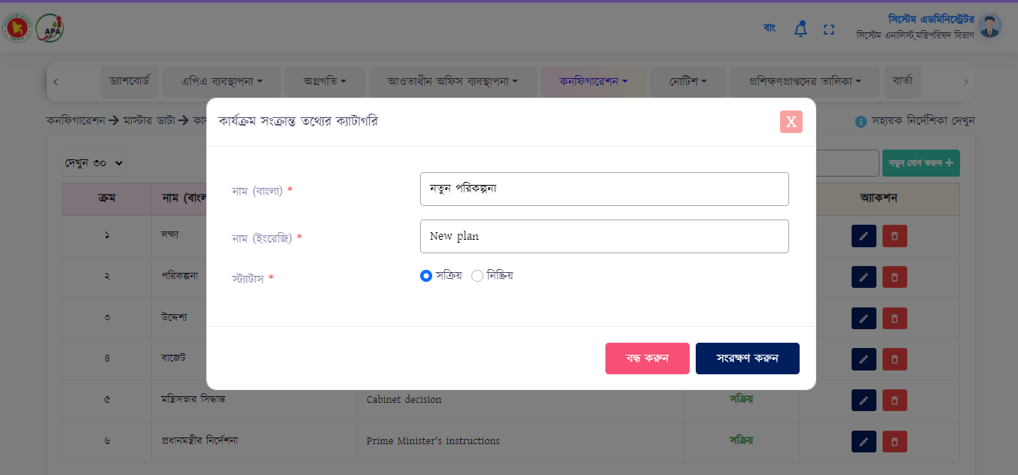

Upon clicking on create button, the data will be uploaded and will be shown in the list.

1. Dashboard Settings

* **Analytics Dashboard->** In this menu user will publish dashboard according to department/organization type. An ID will be generated while embedding from the BI tool. The layer to which the ID will be tagged, when all the users of that layer will login to the system, all will get that dashboard. Here user will add, edit & delete data. User will click “Add New” button to add new data.

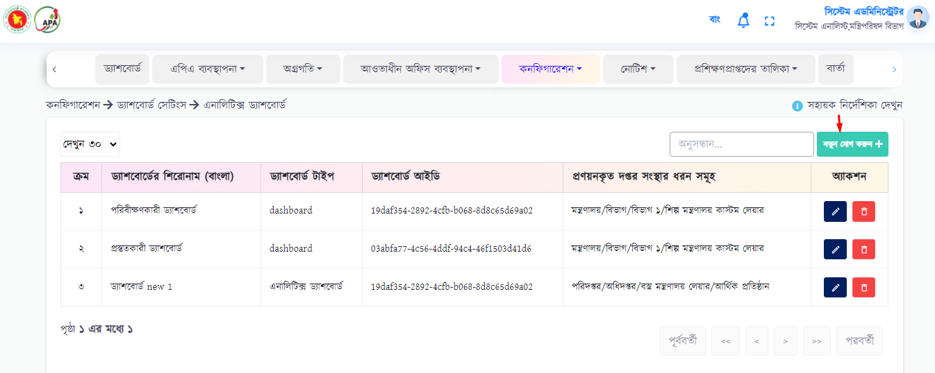

To add new data, user needs to fill the following fields:

* Dashboard title BN*
* Dashboard type*
* Dashboard ID*
* Types of office

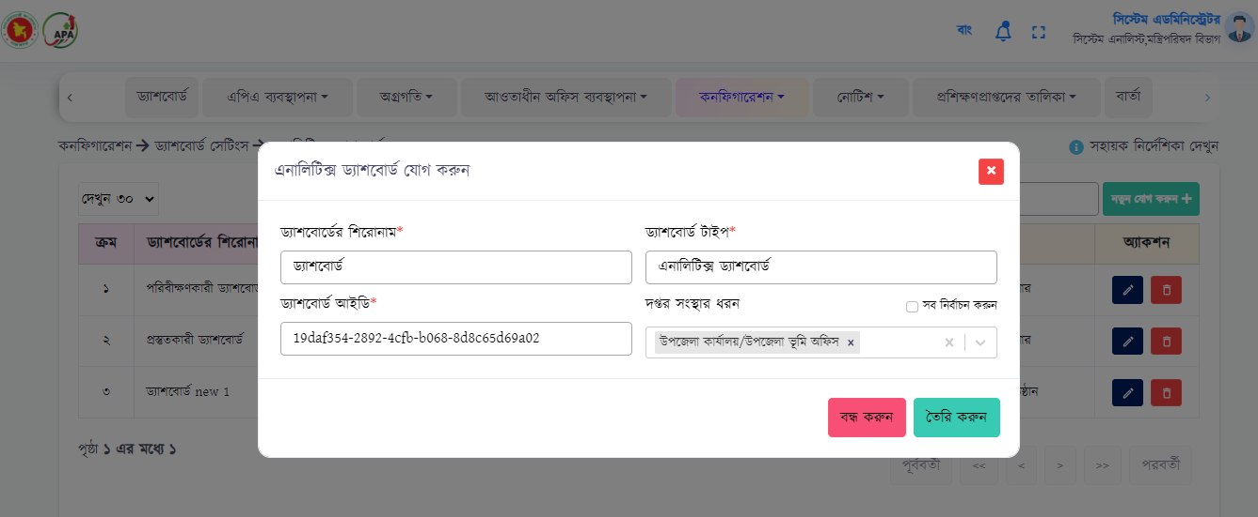

Upon clicking on create button, the data will be uploaded and will be shown in the list.

1. APA Team

In this menu will add details of all members who are involved with APA in all ministries. After adding, user will see the table in the form of a list below.

1. E-Mail Template

E-mail templates will be created in this menu. When the password is set or the password is forgotten, the email template will need to create. User can add, edit and cancel data. User will click “Add New” button to add new data.

To add new data, user needs to fill the following fields:

* Subject
* Greetings
* Message

Upon clicking on create button, the data will be uploaded and will be shown in the list.

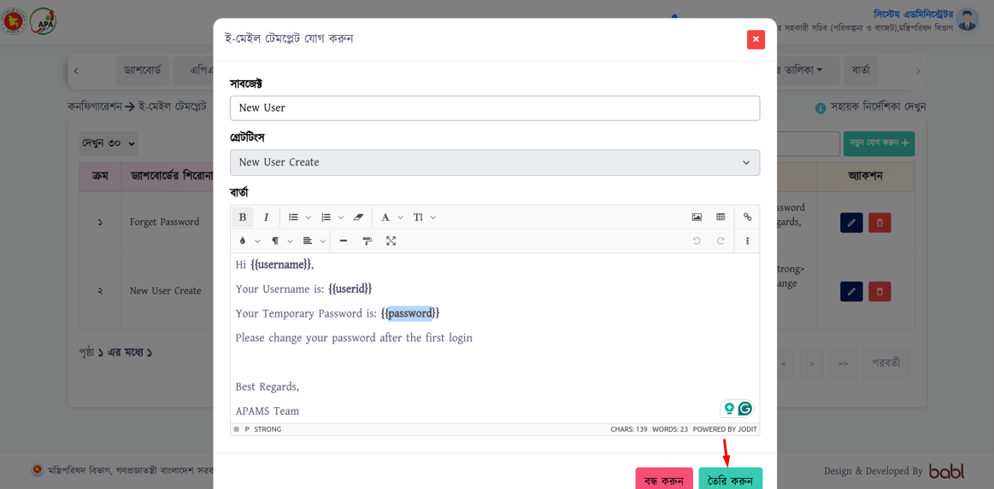

1. User Merge

This menu will be used to merge users from Doptor. When APAMS-v3 needs to bring user from Doptor, but with a different name then this menu will be used.

To merge data, user needs to fill the following fields:

* Office Type*
* Office*
* Nothi User*
* System’s Internal User*

Upon clicking on ‘Merge User’ button, the data will be uploaded and will be shown in the list.

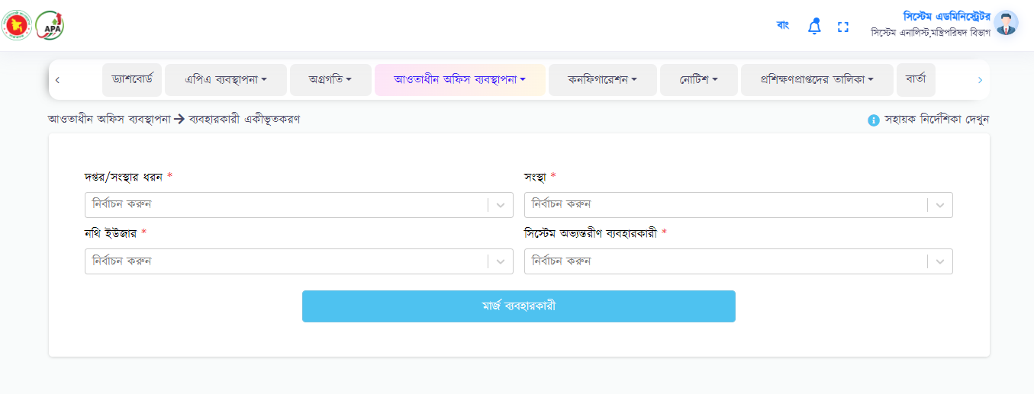

1. Office Merge

This menu will be used to merge office from Doptor. When APAMS-v3 needs to bring office from Doptor, but with a different name then this menu will be used.

To merge data, user needs to fill the following fields:

* Office Type*
* Nothi Office*
* System’s Internal Office*

Upon clicking on ‘Merge Office’ button, the data will be uploaded and will be shown in the list.

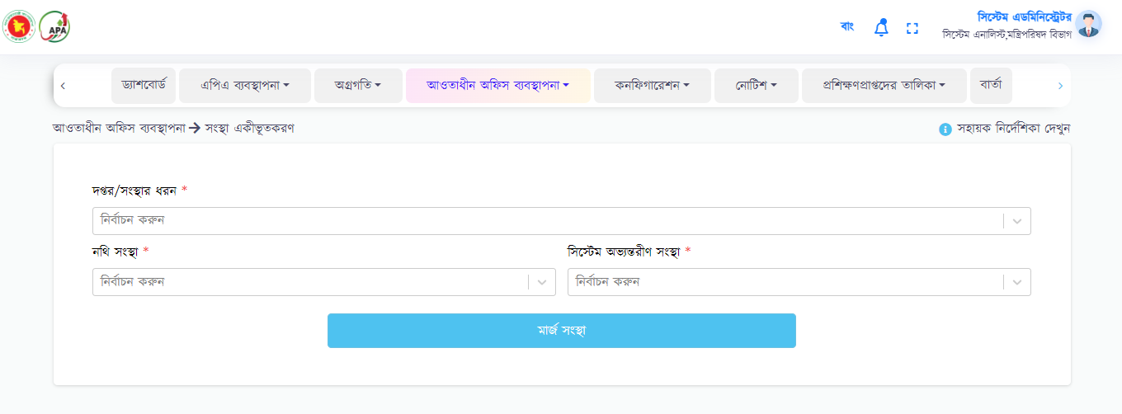

1. Good Governance Activity

This menu will be used to add NIS’s good governance activity ID to APAMS-v3. Then the NIS’s good governance activity ID will be seen in the same ID in APAMS-v3.

To add ID, user needs to fill the following fields:

* Office Type*
* Office*
* type ID*

Upon clicking on ‘create’ button, the data will be uploaded and will be shown in the database list.

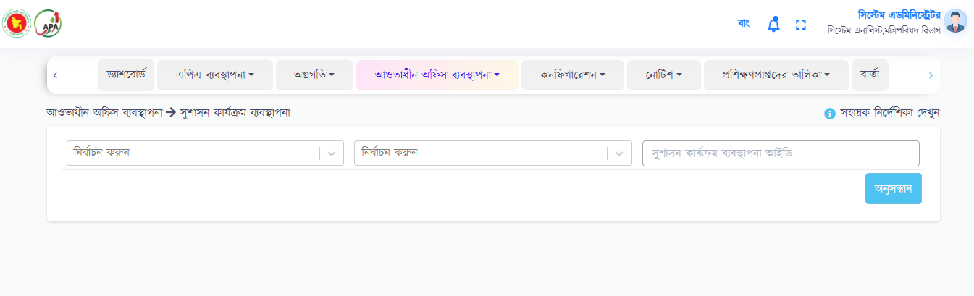

1. Assessment Publication Settings

This sub-menu will be used to control the two columns of the Annual Achievement and Evaluation table.

* If 'Publication Type' selects “Corrected Score” and 'Publication Status' = 'Published', then the 'Corrected Score' column will appear in the Annual Achievement and Evaluation Table.
* If 'Publication Type' is selected as “Higher Authority's Remarks” and 'Publication Status' = 'Published', then the ' Higher Authority's Remarks' column will appear in the Annual Achievement and Evaluation Table.
* If 'Publish Status' = 'Not Published', neither of the two columns will be visible in the Annual Achievement and Evaluation Table.

To set column, user needs to fill the following fields:

* Fiscal Year*
* Office Type*
* Office*
* Publication Status*
* Publication type*

Upon clicking on ‘create’ button, the data will be create and will be shown in the table as user want.

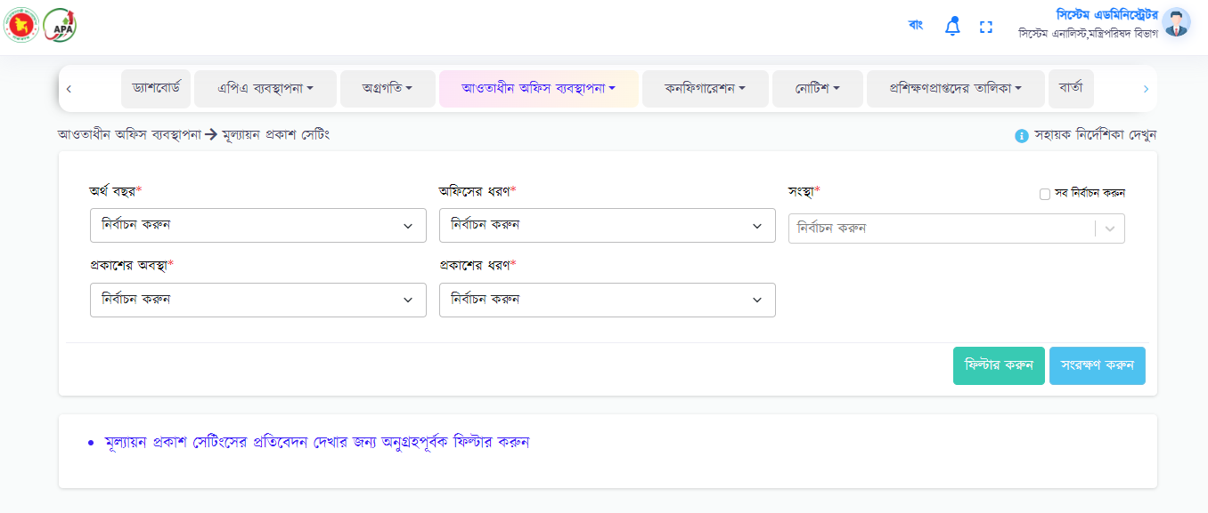

**Mobile APP**

After login, there are 6 menus will appear in the homepage menu bar. That are:

* APA submission information

* Achievement submission information

* Evaluation

* Time setting

* Edit Request

* Report

These six menu’s features are described one by one below:

* **APA submission information->** From this menu user will view the report of any organization under any organogram for any financial year.

In that case, user can select fiscal year, types of layers, submission type and can click on filter button.

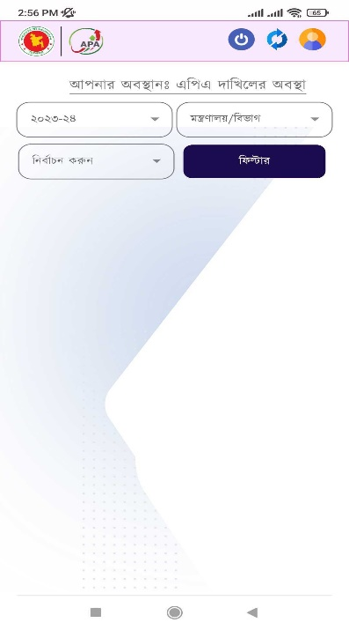

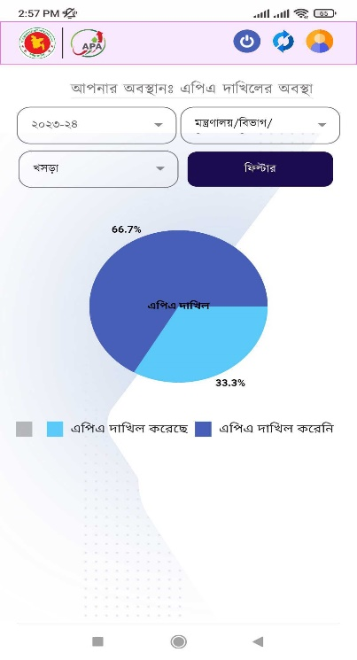

* **Achievement submission information->** The achievement status (submitted/not submitted) can be viewed by the user from this tab. In that case, user can select Fiscal Year, Department/Organization Type, Type, Quarter/Month Type and can able to click on 'Filter' button.

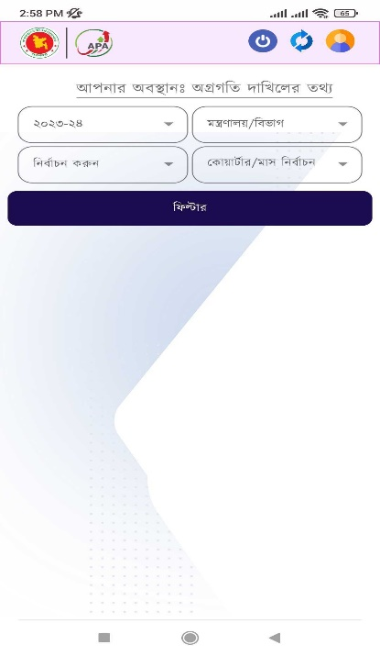

Then user can see how many offices have submitted achievement and how many offices have not submitted the achievement in percentage.

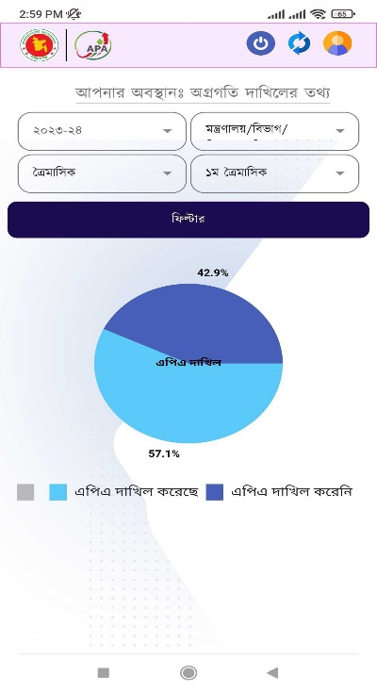

* **Evaluation->** Here at the end of the fiscal year, for example; after the passes of four quarters or 12 months, the user can see the APA evaluation of the subordinate office. In that case, user can select Fiscal Year, Department/Organization Type.

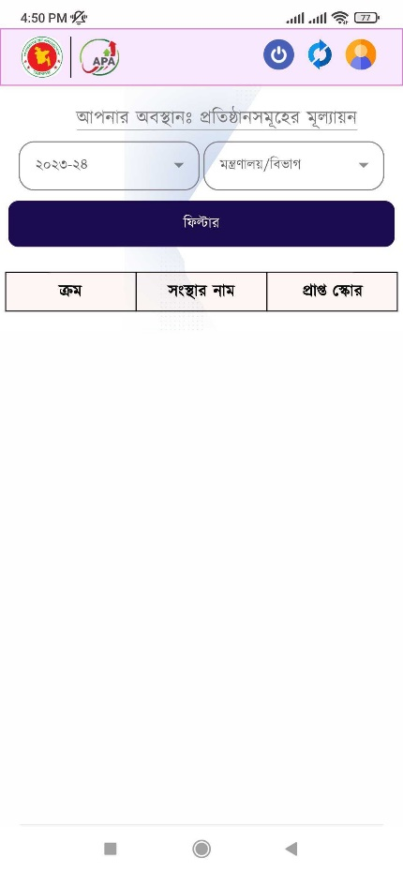

After select all field, user able to click on 'Filter' button. There user can see all the data in the table below.

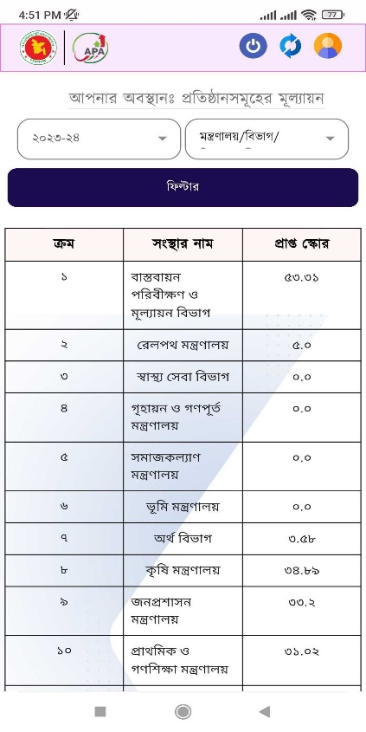

* **APA Time Setting->** Here user can see schedule the APA submission time of the subordinate office. The user can specify the type of the APA submission ie; draft or final. In that case, user can select Fiscal Year, APA Submission Type, Submission Start Date, Submission End Date, Department/Organization Type, Organization. User will able to click on “Save” button to save the data.

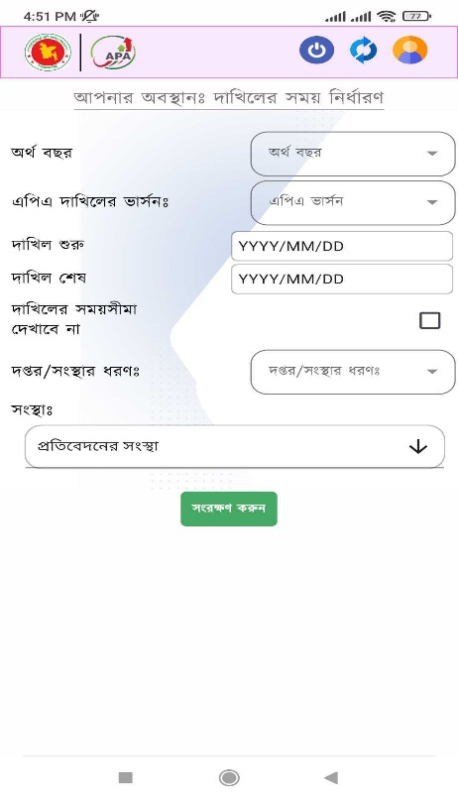

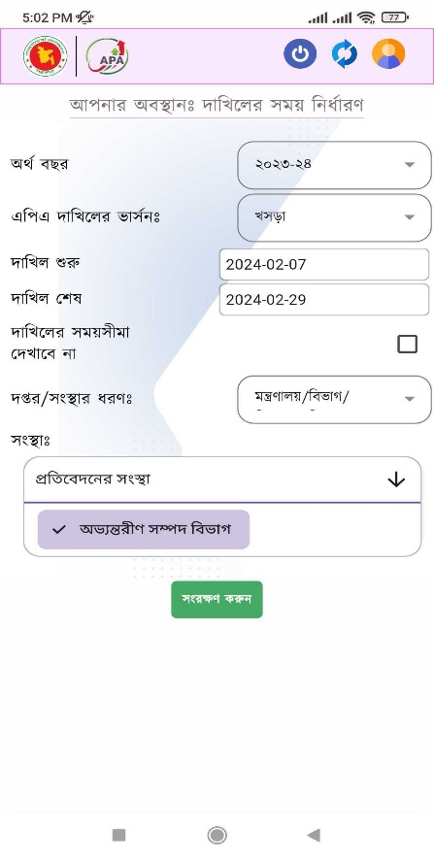

* **Edit Request->** Subordinate Offices will view their respective draft or final APA reports which is request for edit from subordinate offices.

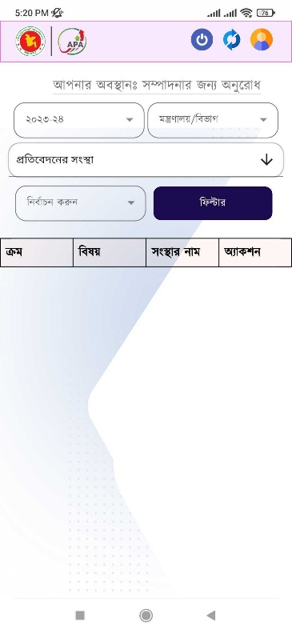

Submission status will be of 3 types – Waiting List, Approved List, Rejected List

Waiting list: If waiting list, user can view APA from action column. In that case, user will select fiscal year, department/organization type, organization, submission status and click on filter button. User can see the data in the table below.

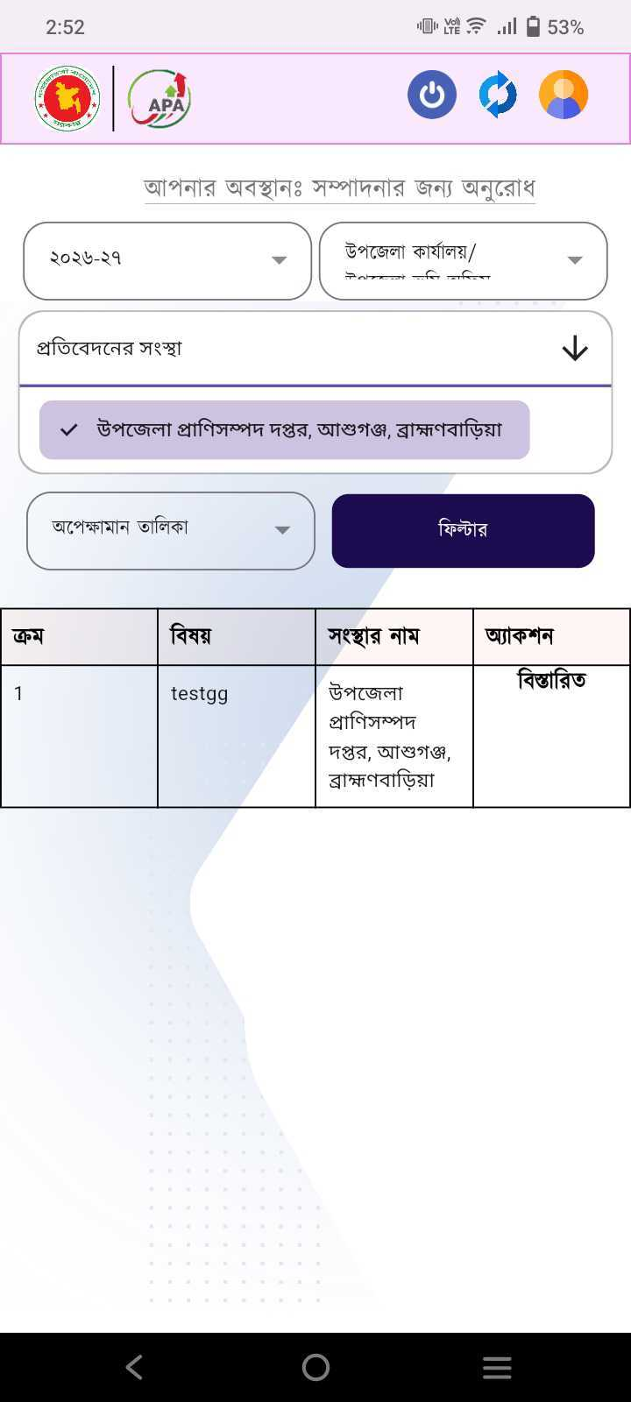

In action column, user will able to see accept, reject & close button. If click accept button, then user will accept that request & select indicator for unlock indicator. If click reject button, then user can reject that request.

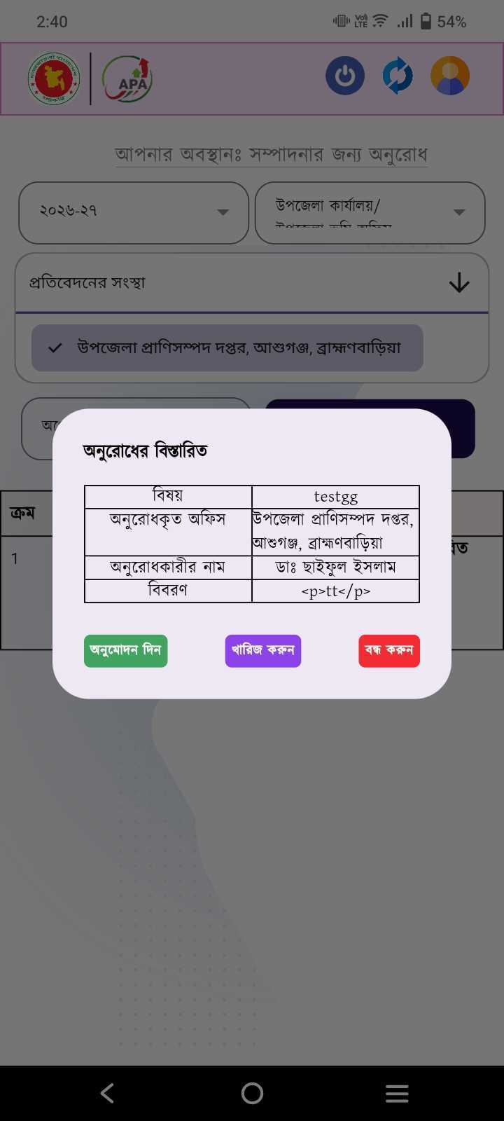

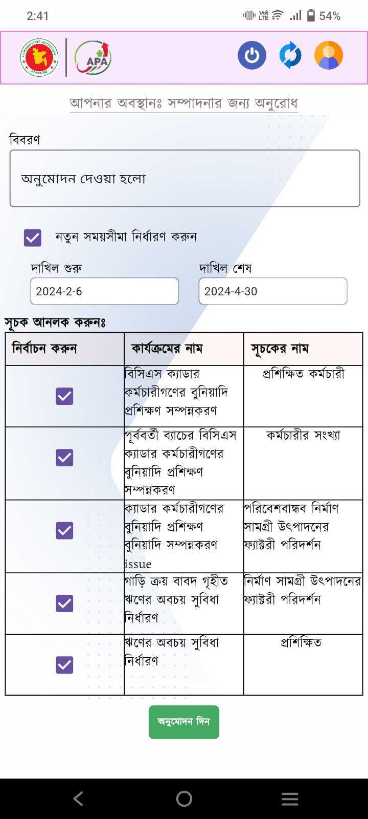

Approval List: User can only view the approval list. In that case, user can select fiscal year, department/organization type, organization, submission status and user will able to click on filter button. User can see the data in the table below.

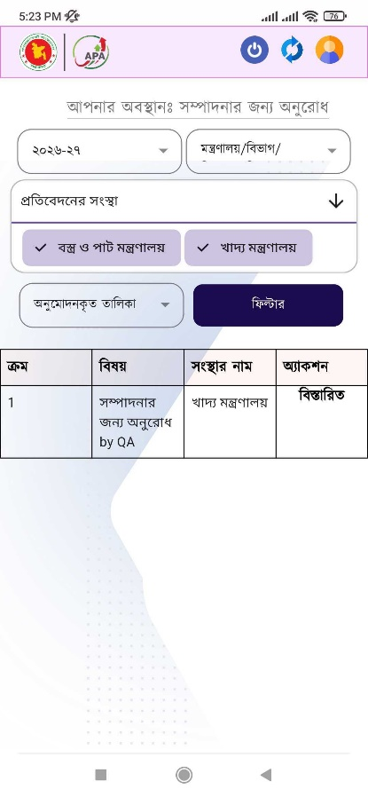

Rejection List: Here user can see the rejection list. In that case, user can select financial year, department/organization type, organization, submission status and able to click on filter button. User can see the data in the table below.

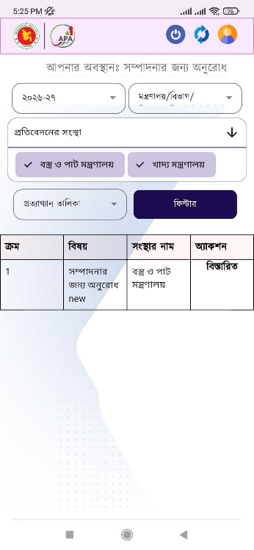

* **Report->** Here user will able to see all types of reports. Such as:
* Full APA Report
* Reports of different parts of the APA
* Quarterly Evaluation report
* Annual Evaluation Report
* Quarterly Achievement report
* Monthly Achievement report
* Organogram’s Evaluation Report

After click on filter button, user will only visible & can download the reports. To filter, user can see below fields:

* Fiscal Year
* Ministry/Division
* Office type
* Office Report
* Report Type
* Quarterly/Monthly

